







Clean and maintain industrial work area and equipment
D1.HHK.CL3.07
Trainer Guide

Clean and maintain industrial work area and equipment

D1.HHK.CL3.07

Trainer Guide





Project Base
William Angliss Institute of TAFE
555 La Trobe Street
Melbourne 3000 Victoria
Telephone: | (03) 9606 2111
Facsimile: | (03) 9670 1330
Acknowledgements
Project Director: | Wayne Crosbie
Chief Writer: | Alan Hickman
Subject Writer: | Barbara Sargeant
Project Manager/Editor: | Alan Maguire
DTP/Production | Daniel Chee, Mai Vu, Jirayu Thangcharoensamut, Kaly Quach

The Association of Southeast Asian Nations (ASEAN) was established on 8 August 1967. The Member States of the Association are Brunei Darussalam, Cambodia, Indonesia, Lao PDR, Malaysia, Myanmar, Philippines, Singapore, Thailand and Viet Nam.
The ASEAN Secretariat is based in Jakarta, Indonesia.
General Information on ASEAN appears online at the ASEAN Website: www.asean.org.
All text is produced by William Angliss Institute of TAFE for the ASEAN Project on “Toolbox Development for Priority Tourism Labour Division”.
This publication is supported by the Australian Government’s aid program through the ASEAN-Australia Development Cooperation Program Phase II (AADCP II).
Copyright: Association of Southeast Asian Nations (ASEAN) 2012.
All rights reserved.
Disclaimer
Every effort has been made to ensure that this publication is free from errors or omissions. However, you should conduct your own enquiries and seek professional advice before relying on any fact, statement or matter contained in this book. The ASEAN Secretariat and William Angliss Institute of TAFE are not responsible for any injury, loss or damage as a result of material included or omitted from this course. Information in this module is current at the time of publication. Time of publication is indicated in the date stamp at the bottom of each page.
Some images appearing in this resource have been purchased from stock photography suppliers Shutterstock and iStockphoto and other third party copyright owners and as such are non-transferable and non-exclusive. Clip arts, font images and illustrations used are from the Microsoft Office Clip Art and Media Library. Some images have been provided by and are the property of William Angliss Institute.
Additional images have been sourced from Flickr and SXC and are used under Creative Commons licence: http://creativecommons.org/licenses/by/2.0/deed.en

File name: TG_Clean_&_maintain_ind_work_area_&_Equip_refined





Table of Contents
Competency Based Training (CBT) and assessment an introduction for trainers 1
Competency standard 11
Notes and PowerPoint slides 23
Recommended training equipment 69
Instructions for Trainers for using PowerPoint – Presenter View 71
Appendix – ASEAN acronyms 73

Competency Based Training (CBT) and assessment an introduction for trainers

Competency
Competency refers to the ability to perform particular tasks and duties to the standard of performance expected in the workplace.
Competency requires the application of specified knowledge, skills and attitudes relevant to effective participation, consistently over time and in the workplace environment.
The essential skills and knowledge are either identified separately or combined.
Knowledge identifies what a person needs to know to perform the work in an informed and effective manner.
Skills describe the application of knowledge to situations where understanding is converted into a workplace outcome.
Attitude describes the founding reasons behind the need for certain knowledge or why skills are performed in a specified manner.
Competency covers all aspects of workplace performance and involves:
- Performing individual tasks
- Managing a range of different tasks
- Responding to contingencies or breakdowns
- Dealing with the responsibilities of the workplace
- Working with others.

Unit of Competency
Like with any training qualification or program, a range of subject topics are identified that focus on the ability in a certain work area, responsibility or function.
Each manual focuses on a specific unit of competency that applies in the hospitality workplace.
In this manual a unit of competency is identified as a ‘unit’.
Each unit of competency identifies a discrete workplace requirement and includes:
- Knowledge and skills that underpin competency
- Language, literacy and numeracy
- Occupational safety and health requirements.
Each unit of competency must be adhered to in training and assessment to ensure consistency of outcomes.

Element of Competency
An element of competency describes the essential outcomes within a unit of competency.
The elements of competency are the basic building blocks of the unit of competency. They describe in terms of outcomes the significant functions and tasks that make up the competency.
In this manual elements of competency are identified as an ‘element’.

Performance criteria
Performance criteria indicate the standard of performance that is required to demonstrate achievement within an element of competency. The standards reflect identified industry skill needs.
Performance criteria will be made up of certain specified skills, knowledge and attitudes.

Learning
For the purpose of this manual learning incorporates two key activities:
- Training
- Assessment.
Both of these activities will be discussed in detail in this introduction.
Today training and assessment can be delivered in a variety of ways. It may be provided to participants:
- On-the-job – in the workplace
- Off-the-job – at an educational institution or dedicated training environment
- As a combination of these two options.
No longer is it necessary for learners to be absent from the workplace for long periods of time in order to obtain recognised and accredited qualifications.

Learning Approaches
This manual will identify two avenues to facilitate learning:
Competency Based Training (CBT)
This is the strategy of developing a participant’s competency.
Educational institutions utilise a range of training strategies to ensure that participants are able to gain the knowledge and skills required for successful:
- Completion of the training program or qualification
- Implementation in the workplace.
The strategies selected should be chosen based on suitability and the learning styles of participants.

Competency Based Assessment (CBA)
This is the strategy of assessing competency of a participant.
Educational institutions utilise a range of assessment strategies to ensure that participants are assessed in a manner that demonstrates validity, fairness, reliability, flexibility and fairness of assessment processes.

Flexibility in Learning
It is important to note that flexibility in training and assessment strategies is required to meet the needs of participants who may have learning difficulties. The strategies used will vary, taking into account the needs of individual participants with learning difficulties. However they will be applied in a manner which does not discriminate against the participant or the participant body as a whole.
Catering for Participant Diversity
Participants have diverse backgrounds, needs and interests. When planning training and assessment activities to cater for individual differences, trainers and assessors should:
- Consider individuals’ experiences, learning styles and interests
- Develop questions and activities that are aimed at different levels of ability
- Modify the expectations for some participants
- Provide opportunities for a variety of forms of participation, such as individual, pair and small group activities
- Assess participants based on individual progress and outcomes.
The diversity among participants also provides a good reason for building up a learning community in which participants support each other’s learning.
Participant Centred Learning
This involves taking into account structuring training and assessment that:
- Builds on strengths – Training environments need to demonstrate the many positive features of local participants (such as the attribution of academic success to effort, and the social nature of achievement motivation) and of their trainers (such as a strong emphasis on subject disciplines and moral responsibility). These strengths and uniqueness of local participants and trainers should be acknowledged and treasured
- Acknowledges prior knowledge and experience – The learning activities should be planned with participants’ prior knowledge and experience in mind
- Understands learning objectives – Each learning activity should have clear learning objectives and participants should be informed of them at the outset. Trainers should also be clear about the purpose of assignments and explain their significance to participants
- Teaches for understanding – The pedagogies chosen should aim at enabling participants to act and think flexibly with what they know
- Teaches for independent learning – Generic skills and reflection should be nurtured through learning activities in appropriate contexts of the curriculum. Participants should be encouraged to take responsibility for their own learning
- Enhances motivation – Learning is most effective when participants are motivated. Various strategies should be used to arouse the interest of participants
- Makes effective use of resources – A variety of teaching resources can be employed as tools for learning
- Maximises engagement – In conducting learning activities, it is important for the minds of participants to be actively engaged
- Aligns assessment with learning and teaching – Feedback and assessment should be an integral part of learning and teaching
- Caters for learner diversity – Trainers should be aware that participants have different characteristics and strengths and try to nurture these rather than impose a standard set of expectations.
Active Learning
The goal of nurturing independent learning in participants does not imply that they always have to work in isolation or solely in a classroom. On the contrary, the construction of knowledge in tourism and hospitality studies can often best be carried out in collaboration with others in the field. Sharing experiences, insights and views on issues of common concern, and working together to collect information through conducting investigative studies in the field (active learning) can contribute a lot to their eventual success.
Active learning has an important part to play in fostering a sense of community in the class. First, to operate successfully, a learning community requires an ethos of acceptance and a sense of trust among participants, and between them and their trainers. Trainers can help to foster acceptance and trust through encouragement and personal example, and by allowing participants to take risks as they explore and articulate their views, however immature these may appear to be. Participants also come to realise that their classmates (and their trainers) are partners in learning and solving.
Trainers can also encourage cooperative learning by designing appropriate group learning tasks, which include, for example, collecting background information, conducting small-scale surveys, or producing media presentations on certain issues and themes. Participants need to be reminded that, while they should work towards successful completion of the field tasks, developing positive peer relationships in the process is an important objective of all group work.

Competency Based Training (CBT)
Principle of Competency Based Training
Competency based training is aimed at developing the knowledge, skills and attitudes of participants, through a variety of training tools.
Training Strategies
The aims of this curriculum are to enable participants to:
- Undertake a variety of subject courses that are relevant to industry in the current environment
- Learn current industry skills, information and trends relevant to industry
- Learn through a range of practical and theoretical approaches
- Be able to identify, explore and solve issues in a productive manner
- Be able to become confident, equipped and flexible managers of the future
- Be ‘job ready’ and a valuable employee in the industry upon graduation of any qualification level.
To ensure participants are able to gain the knowledge and skills required to meet competency in each unit of competency in the qualification, a range of training delivery modes are used.
Types of Training
In choosing learning and teaching strategies, trainers should take into account the practical, complex and multi-disciplinary nature of the subject area, as well as their participant’s prior knowledge, learning styles and abilities.
Training outcomes can be attained by utilising one or more delivery methods:
Lecture/Tutorial
This is a common method of training involving transfer of information from the trainer to the participants. It is an effective approach to introduce new concepts or information to the learners and also to build upon the existing knowledge. The listener is expected to reflect on the subject and seek clarifications on the doubts.
Demonstration
Demonstration is a very effective training method that involves a trainer showing a participant how to perform a task or activity. Through a visual demonstration, trainers may also explain reasoning behind certain actions or provide supplementary information to help facilitate understanding.
Group Discussions
Brainstorming in which all the members in a group express their ideas, views and opinions on a given topic, is a free flow and exchange of knowledge among the participants and the trainer. The discussion is carried out by the group on the basis of their own experience, perceptions and values. This will facilitate acquiring new knowledge. When everybody is expected to participate in the group discussion, even the introverted persons will also get stimulated and try to articulate their feelings.
The ideas that emerge in the discussions should be noted down and presentations are to be made by the groups. Sometimes consensus needs to be arrived at on a given topic. Group discussions are to be held under the moderation of a leader guided by the trainer. Group discussion technique triggers thinking process, encourages interactions and enhances communication skills.
Role Play
This is a common and very effective method of bringing into the classroom real life situations, which may not otherwise be possible. Participants are made to enact a particular role so as to give a real feel of the roles they may be called upon to play. This enables participants to understand the behaviour of others as well as their own emotions and feelings. The instructor must brief the role players on what is expected of them. The role player may either be given a ready-made script, which they can memorise and enact, or they may be required to develop their own scripts around a given situation. This technique is extremely useful in understanding creative selling techniques and human relations. It can be entertaining and energising and it helps the reserved and less literate to express their feelings.

Simulation Games
When trainees need to become aware of something that they have not been conscious of, simulations can be a useful mechanism. Simulation games are a method based on "here and now" experience shared by all the participants. The games focus on the participation of the trainees and their willingness to share their ideas with others. A "near real life" situation is created providing an opportunity to which they apply themselves by adopting certain behaviour. They then experience the impact of their behaviour on the situation. It is carried out to generate responses and reactions based on the real feelings of the participants, which are subsequently analysed by the trainer.
While use of simulation games can result in very effective learning, it needs considerable trainer competence to analyse the situations.
Individual /Group Exercises
Exercises are often introduced to find out how much the participant has assimilated. This method involves imparting instructions to participants on a particular subject through use of written exercises. In the group exercises, the entire class is divided into small groups, and members are asked to collaborate to arrive at a consensus or solution to a problem.
Case Study
This is a training method that enables the trainer and the participant to experience a real life situation. It may be on account of events in the past or situations in the present, in which there may be one or more problems to be solved and decisions to be taken. The basic objective of a case study is to help participants diagnose, analyse and/or solve a particular problem and to make them internalise the critical inputs delivered in the training. Questions are generally given at the end of the case study to direct the participants and to stimulate their thinking towards possible solutions. Studies may be presented in written or verbal form.
Field Visit
This involves a carefully planned visit or tour to a place of learning or interest. The idea is to give first-hand knowledge by personal observation of field situations, and to relate theory with practice. The emphasis is on observing, exploring, asking questions and understanding. The trainer should remember to brief the participants about what they should observe and about the customs and norms that need to be respected.
Group Presentation
The participants are asked to work in groups and produce the results and findings of their group work to the members of another sub-group. By this method participants get a good picture of each other's views and perceptions on the topic and they are able to compare them with their own point of view. The pooling and sharing of findings enriches the discussion and learning process.
Practice Sessions
This method is of paramount importance for skills training. Participants are provided with an opportunity to practice in a controlled situation what they have learnt. It could be real life or through a make-believe situation.

Games
This is a group process and includes those methods that involve usually fun-based activity, aimed at conveying feelings and experiences, which are everyday in nature, and applying them within the game being played. A game has set rules and regulations, and may or may not include a competitive element. After the game is played, it is essential that the participants be debriefed and their lessons and experiences consolidated by the trainer.
Research
Trainers may require learners to undertake research activities, including online research, to gather information or further understanding about a specific subject area.

Competency Based Assessment (CBA)
Principle of Competency Based Assessment
Competency based assessment is aimed at compiling a list of evidence that shows that a person is competent in a particular unit of competency.
Competencies are gained through a multitude of ways including:
- Training and development programs
- Formal education
- Life experience
- Apprenticeships
- On-the-job experience
- Self-help programs.
All of these together contribute to job competence in a person. Ultimately, assessors and participants work together, through the ‘collection of evidence’ in determining overall competence.
This evidence can be collected:
- Using different formats
- Using different people
- Collected over a period of time.
The assessor, who is ideally someone with considerable experience in the area being assessed, reviews the evidence and verifies the person as being competent or not.
Flexibility in Assessment
Whilst allocated assessment tools have been identified for this subject, all attempts are made to determine competency and suitable alternate assessment tools may be used, according to the requirements of the participant.
The assessment needs to be equitable for all participants, taking into account their cultural and linguistic needs.
Competency must be proven regardless of:
- Language
- Delivery Method
- Assessment Method.
Assessment Objectives
The assessment tools used for subjects are designed to determine competency against the ‘elements of competency’ and their associated ‘performance criteria’.
The assessment tools are used to identify sufficient:
- Knowledge, including underpinning knowledge
- Skills
- Attitudes
Assessment tools are activities that trainees are required to undertake to prove participant competency in this subject.
All assessments must be completed satisfactorily for participants to obtain competence in this subject. There are no exceptions to this requirement, however, it is possible that in some cases several assessment items may be combined and assessed together.
Types of Assessment
Allocated Assessment Tools
There are a number of assessment tools that are used to determine competency in this subject:
- Work projects
- Written questions
- Oral questions
- Third Party Report
- Observation Checklist.
Instructions on how assessors should conduct these assessment methods are explained in the Assessment Manuals.
Alternative Assessment Tools
Whilst this subject has identified assessment tools, as indicated above, this does not restrict the assessor from using different assessment methods to measure the competency of a participant.
Evidence is simply proof that the assessor gathers to show participants can actually do what they are required to do.
Whilst there is a distinct requirement for participants to demonstrate competency, there are many and diverse sources of evidence available to the assessor.
Ongoing performance at work, as verified by a supervisor or physical evidence, can count towards assessment. Additionally, the assessor can talk to customers or work colleagues to gather evidence about performance.
A range of assessment methods to assess competency include:
- Practical demonstrations
- Practical demonstrations in simulated work conditions
- Problem solving
- Portfolios of evidence
- Critical incident reports
- Journals
- Oral presentations
- Interviews
- Videos
- Visuals: slides, audio tapes
- Case studies
- Log books
- Projects
- Role plays
- Group projects
- Group discussions
- Examinations.
Recognition of Prior Learning
Recognition of Prior Learning is the process that gives current industry professionals who do not have a formal qualification, the opportunity to benchmark their extensive skills and experience against the standards set out in each unit of competency/subject.
Also known as a Skills Recognition Audit (SRA), this process is a learning and assessment pathway which encompasses:
- Recognition of Current Competencies (RCC)
- Skills auditing
- Gap analysis and training
- Credit transfer.
Assessing competency
As mentioned, assessment is the process of identifying a participant’s current knowledge, skills and attitudes sets against all elements of competency within a unit of competency. Traditionally in education, grades or marks were given to participants, dependent on how many questions the participant successfully answered in an assessment tool.
Competency based assessment does not award grades, but simply identifies if the participant has the knowledge, skills and attitudes to undertake the required task to the specified standard.
Therefore, when assessing competency, an assessor has two possible results that can be awarded:
- Pass Competent (PC)
- Not Yet Competent (NYC).
Pass Competent (PC)
If the participant is able to successfully answer or demonstrate what is required, to the expected standards of the performance criteria, they will be deemed as ‘Pass Competent’ (PC).
The assessor will award a ‘Pass Competent’ (PC) if they feel the participant has the necessary knowledge, skills and attitudes in all assessment tasks for a unit.
Not Yet Competent’ (NYC)
If the participant is unable to answer or demonstrate competency to the desired standard, they will be deemed to be ‘Not Yet Competent’ (NYC).
This does not mean the participant will need to complete all the assessment tasks again. The focus will be on the specific assessment tasks that were not performed to the expected standards.
The participant may be required to:
a) Undertake further training or instruction
b) Undertake the assessment task again until they are deemed to be ‘Pass Competent’.

Competency standard
UNIT TITLE: CLEAN AND MAINTAIN INDUSTRIAL WORK AREA AND EQUIPMENT |  |  |  | NOMINAL HOURS: | 40
UNIT NUMBER: D1.HHK.CL3.07
UNIT DESCRIPTOR: This unit deals with skills and knowledge required to clean and maintain industrial work areas and equipment within a housekeeping context.
ELEMENTS AND PERFORMANCE CRITERIA | UNIT VARIABLE AND ASSESSMENT GUIDE
Element 1: Identify cleaning and maintenance requirements  - Identify work areas to be cleaned and maintained  - Identify work equipment to be cleaned and maintained  - Identify and locate instructions in relation to cleaning and maintenance  Element 2: Clean industrial work areas  - Assess area to be cleaned  - Select appropriate cleaning equipment and chemicals  - Select the protective clothing and equipment to be used  - Prepare the area  - Undertake the selected cleaning process  - Dispose of waste  - Return area to operational condition  - Clean, check and store cleaning equipment and chemicals  Element 3: Clean industrial work equipment  - Assess suitability of equipment for cleaning  - Select appropriate cleaning equipment and chemicals  - Select the protective clothing and equipment to be used  - Prepare equipment for cleaning  - Clean equipment as identified  - Tidy work site  - Dispose of waste  - Clean, check and store cleaning equipment and chemicals  Element 4: Maintain industrial work areas and equipment  - Identify maintenance tasks to be undertaken  - Perform maintenance tasks, as required  - Report problems and faults that require additional attention  - Store maintenance items and equipment  - Perform required administrative tasks  - Assist in special projects, where required  - Liaise with external contractors | Unit Variables  The Unit Variables provide advice to interpret the scope and context of this unit of competence, allowing for differences between enterprises and workplaces. It relates to the unit as a whole and facilitates holistic assessment.  This unit applies to all industry sectors that undertake in-house provision of cleaning and maintenance of industrial work areas and equipment within the labour divisions of the hotel and travel industries and may include:  - Housekeeping.  Work areas to be cleaned and maintained may include walls, floors, windows and ceilings of:  - Internal work areas, including offices, foyers, entertainment facilities, kitchen facilities, functions areas and back-of-house facilities  - External work areas, including parking areas, maintenance facilities, driveways, footpaths and roofs of buildings.  Equipment to be cleaned and maintained may include:  - Back-of-house items  - Front-of-house items  - Cleaning in place (CIP) equipment.  Instructions in relation to cleaning and maintenance may include:  - Manufacturer’s instructions  - Job safety analysis sheets  - Scheduled maintenance sheets  - Work instructions and work orders  - Safety advice  - Material safety data sheets  - Specific cleaning instructions  - Instructional guides  - Operation manuals  - Standard operating procedures  - Specifications.  Assess area may include:  - Identifying cleaning techniques to be applied  - Identifying access, including timing and physical access elements  - Evaluating options  - Identifying soil type  - Confirming condition of area to be cleaned  - Assessing damage to the area and evaluating its impact on cleaning activities  - Reporting issues that need to be addressed by other personnel, including internal and external personnel.  Cleaning equipment may include:  - Pressure and high pressure washers  - Steam cleaners  - Ride-on equipment, including scrubber dryers, sweepers and combination units  - Floor polishers, burnishers and buffers  - Portable spotters/extractors  - Industrial vacuum cleaners, including wet and dry  - Vacuum litter collectors and blowers  - High speed surface cleaners  - Mops and brooms  - Buckets  - Cloths and dusters  - Pans  - Garbage receptacles.  Chemicals may include:  - Acid cleaners and brighteners  - Bowl cleaners  - Carpet care products  - Rust inhibitors, phosphatisers and rinse additives  - Detergents of all types and strengths including pre-treatment agents  - Emulsion cleaners, including drain cleaners, degreasers  - Floor cleaners  - Powdered and liquid chemicals  - Solvent cleaners  - Steam cleaners.  Protective clothing and equipment may include:  - Overalls  - Jackets  - High visibility vests/clothing  - Aprons  - Safety shoes and boots  - Ear muffs and ear plugs  - Goggles and masks  - Gloves and gauntlets  - Waterproof clothing and footwear  - Respirators  - Headwear, helmets and hair nets  - Weather protection.  Prepare the area may include:  - Placement of physical barriers and safety signage  - Moving and/or removing equipment, items and fittings  - Notifying other staff and/or patrons  - Cooperating with others to minimize interruption  - Covering equipment, items, etc with protective material, drop cloths, etc  - Identifying and complying with relevant in-house policies, procedures or other emerging needs.  The selected cleaning process may include:  - Sweeping, including manual, walk-behind and ride-on  - Vacuuming, including wet and dry  - Hosing down, including pressure and high-pressure washing  - Air blowing  - Scrubbing, washing, wiping, spot cleaning, rinsing and pre-spraying  - Stripping, re-sealing and polishing  - Blasting, including sand, water, steam, powder and dry ice  - Specific removal procedures for items such as graffiti, gum, grease and oil  - Mopping, including wet and dry  - High level cleaning  - Wet and dry area cleaning.  Dispose of waste may include:  - Flushing cleaning chemicals from areas  - Capturing waste created as part of the cleaning process  - Alignment with enterprise policies and procedures  - Compliance with local legislation and regulations  - Observing environmental sensitivity issues  - Using external registered and certified waste disposal contractors.  Return area to operational condition may include:  - Replacing items that were moved back into original position  - Replacing items into designated positions as identified by work orders  - Cooperating with other staff to establish a suitable operational area at the start of shift/trade  - Removing barriers and signage  - Opening the site/area for staff and public access, as appropriate  - Notifying relevant supervisors of operational readiness of area.  Clean, check and store cleaning equipment and chemicals may include:  - Cleaning equipment that has been used  - Cleaning personal protective equipment and clothing that has been used, as appropriate  - Conduct safety checks on equipment  - Undertaking basic preventative maintenance and basic repairs on equipment  - Storing equipment in accordance with enterprise requirements  - Storing chemicals in accordance with legislated requirements of the host country and enterprise requirements  - Replenishing consumables.  Assess suitability of equipment for cleaning may include:  - Identifying cleaning techniques to be applied  - Identifying access, including timing and physical access elements  - Evaluating options  - Confirming condition of area to be cleaned  - Assessing damage to the area and evaluating its impact on cleaning activities  - Reporting issues that need to be addressed by other personnel, including internal and external personnel.  Prepare equipment for cleaning may include:  - Confirming and re-assessing hazards  - Controlling identified risks, including turning power off, isolating equipment and tagging out  - Erecting safety signage and barriers to warn public and prevent unauthorized access  - Covering and securing other items and equipment, as appropriate  - Identifying supplementary work restrictions that apply to individual jobs in individual circumstances.  Clean equipment may include:  - Preparing heavily soiled areas in accordance with manufacturer’s instructions and enterprise requirements  - Using appropriate cleaning techniques, equipment and chemicals to remove the identified dirt  - Protecting against over-spray  - Ensuring equipment switches and settings are not changed during the cleaning process  - Using appropriate extension tools to reach difficult places  - Dismantling equipment in accordance with manufacturer’s instructions or work sheets  - Complying with identified and required cleaning activities, including cleaning of nominated areas within/on the equipment  - Inspecting equipment for residual spots, marks and soil  - Undertaking remedial cleaning and supplementary spot cleaning, as required.  Maintenance tasks can apply to industrial work areas and industrial equipment and may include:  - Routine maintenance tasks  - Simple repairs  - Painting and re-decorating  - Adjustments to equipment to compensate for operational issues and can be identified via:  - Manufacturer’s instructions  - Scheduled maintenance sheets  - Requests for maintenance  - Personal observation  - Feedback from employees and members of the public.  Perform maintenance tasks may include:  - Responding promptly to requests for maintenance  - Selecting and using appropriate safety equipment  - Carrying out maintenance tasks according to required schedules and priorities  - Minimizing disruption to customers and operational needs  - Enclosing and/or isolating the work area to enhance safety.  Report problems and faults may include:  - Providing written and verbal reports  - Describing the location and type of problem fault, including identification of site/equipment, explaining potential for damage and/or injury, prioritizing need, suggesting action that needs to be taken.  Store maintenance items and equipment may include:  - Counting items back into store  - Storing equipment, etc into designated areas  - Replenishing consumables that have been used  - Requisitioning additional materials, equipment and items needed.  Administrative tasks may include:  - Completing work report/forms  - Calculating cost of materials used  - Updating scheduled maintenance sheets  - Forwarding documentation to the relevant personnel and/or departments.  Special projects may include:  - Introduction and installation of new equipment into the workplace  - Bringing new equipment on-line  - Removing old equipment from the workplace  - Participating in scheduled preventative maintenance programs  - Participating in major scheduled services.  Liaise with external contractors may include:  - Providing advice to external contractors regarding previous performance of equipment  - Identifying feeds, supplies, contacts, utilities and other workplace information regarding the item being serviced/maintained  - Assisting in carrying, loading and general duties.  Assessment Guide  The following skills and knowledge must be assessed as part of this unit:  - The enterprise’s policies and procedures in regard to cleaning and maintenance of work areas and equipment including occupational safety and health requirements  - The occupational safety and health requirements of the host country as they apply to cleaning and maintenance duties  - The occupational safety and health requirements of the host country relating to cleaning agents and chemicals, including required signage and documentation  - Ability to use general maintenance techniques, tools and equipment  - Principles of scheduled and preventative maintenance  - Environmental principles and host country legislation regarding waste disposal, including the disposal of chemicals  - Ability to use industrial cleaning equipment and techniques  - Reporting requirements relating to cleaning and maintenance  - The role of external third party providers, including cleaners and maintenance providers.  Linkages To Other Units  - Clean public areas, facilities and equipment  - Clean and prepare rooms for in-coming guests  - Clean premises and equipment  - Establish and maintain a safe and secure workplace  - Maintain the safety of premises and personnel  - Implement occupational safety and health procedures  - Follow safety and security procedures.  Critical Aspects of Assessment  Evidence of the following is essential:  - Understanding of host enterprise policies and procedures in regard to cleaning and maintenance of work areas and equipment, including occupational safety and health requirements  - Demonstrated ability to apply at least three nominated cleaning activities to designated industrial work areas and equipment in a safe and effective manner  - Demonstrated ability to provide at least three nominated basic maintenance activities to designated industrial work areas and equipment in a safe and effective manner.  Context of Assessment  Assessment must ensure:  - Practical demonstration either in the workplace or through a simulation activity, supported by a range of methods to assess underpinning knowledge; and it is related to the individual’s work area, or area of responsibility.  Resource Implications  Training and assessment must include access to a real or simulated workplace; and access to actual workplace standards, procedures, policies, guidelines, tools and equipment.  Assessment Methods  The following methods may be used to assess competency for this unit:  - Observation of practical candidate performance  - Evaluation of completed cleaning and maintenance activities against established criteria  - Oral and written questions  - Third party reports completed by a supervisor  - Project and assignment work.
Key Competencies in this Unit
Level 1 = competence to undertake tasks effectively
Level 2 = competence to manage tasks
Level 3 = competence to use concepts for evaluating
 | Key Competencies | Level | Examples
 | Collecting, organising and analysing information | 2 | Read instructions and labels, cleaning schedules, maintenance requirements
 | Communicating ideas and information | 1 | Report maintenance needs and cleaning issues to others
 | Planning and organizing activities | 2 | Schedule cleaning and maintenance activities
 | Working with others and in teams | 1 | Liaise with staff to address identified needs and problems; undertake cleaning activities to support emerging workplace demands
 | Using mathematical ideas and techniques | 1 | Calculate quantities of chemicals required for cleaning
 | Solving problems | 2 | Provide responses to address identified work area and equipment maintenance needs
 | Using technology | 1 | Operate cleaning equipment and repair tools

Notes and PowerPoint slides
Slide
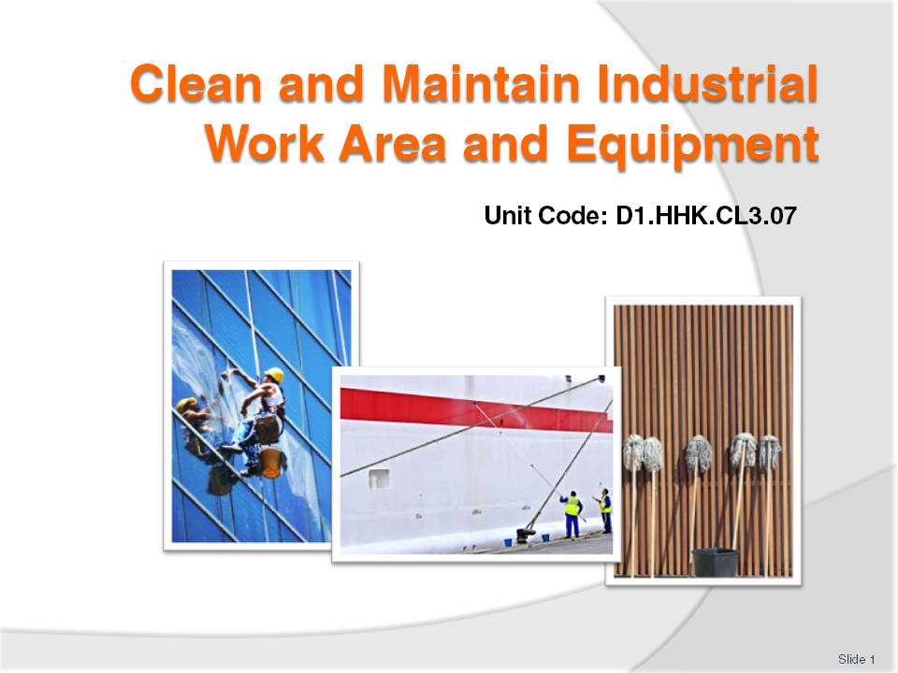
Slide No | Trainer Notes
 | Trainer welcomes trainees to class and introduces the module.

Slide
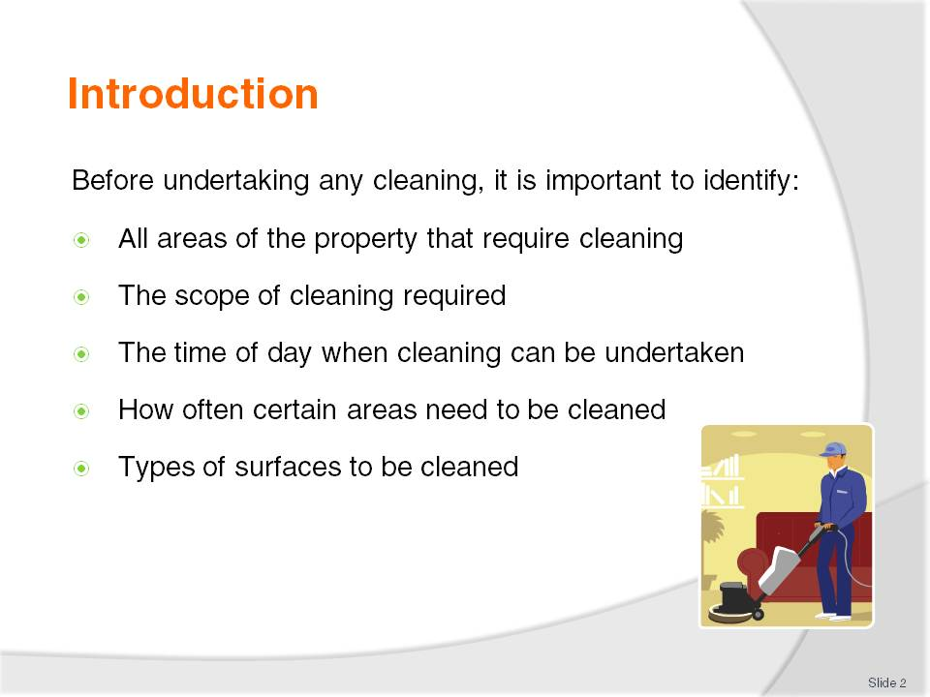
Slide No | Trainer Notes
Class activity 1
Trainer should explain that all properties are different.
Trainer should have the students discuss different types of public buildings and identify all areas within that would require cleaning e.g. School, Church, Bank, Railway station.
Have the students talk about the different traffic flows and expectations of visitors to these places.

Slide
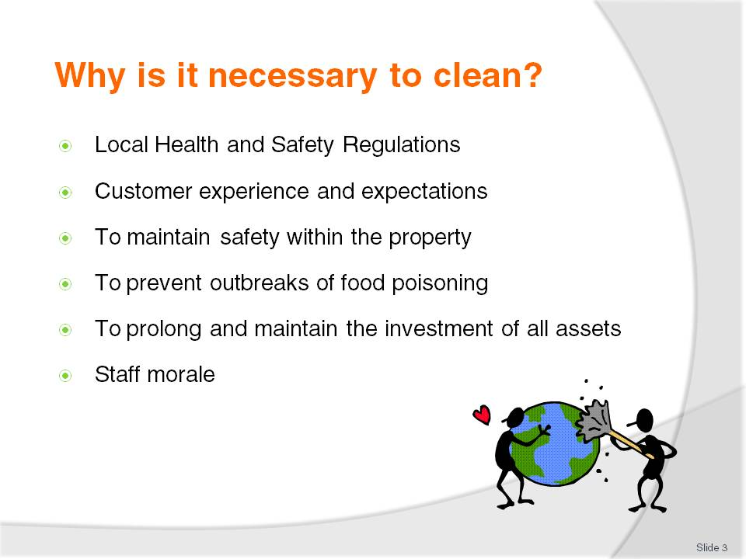
Slide No | Trainer Notes
Trainer to investigate local regulations as they relate to cleaning of premises and share these with students.
Give some examples of where local businesses have had to close through lack of safety or food poisoning outbreaks (newspaper cuttings) and any legal action that followed.

Slide
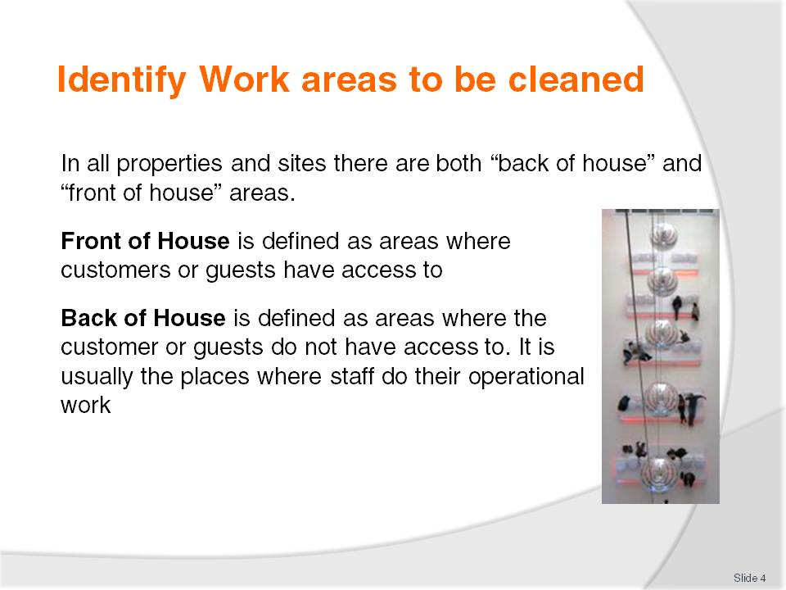
Slide No | Trainer Notes
Trainer to discuss briefly.
Class activity 2
Have the students think about their workplace and what they define as front or back of house. Discuss if there is any difference in cleaning standard and if so why?

Slide
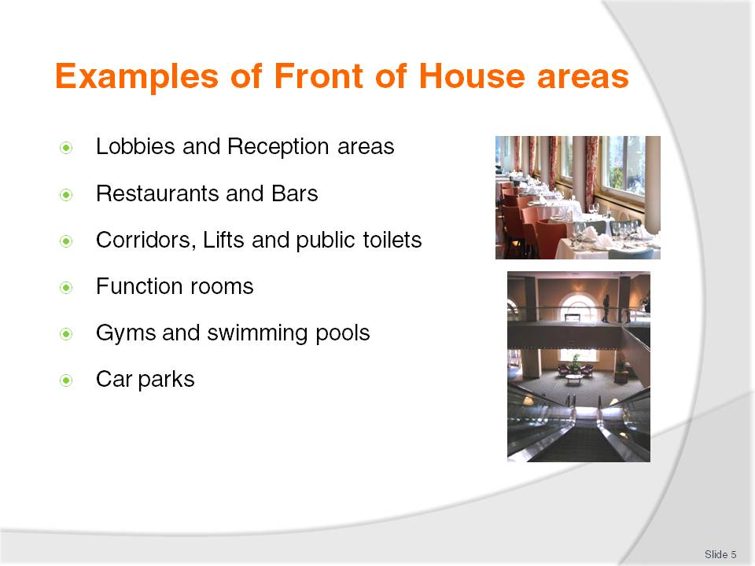
Slide No | Trainer Notes
Trainer to explain that Housekeeping will clean all these areas at different times.
The pH level of swimming pool water however will be checked and controlled by maintenance staff.

Slide
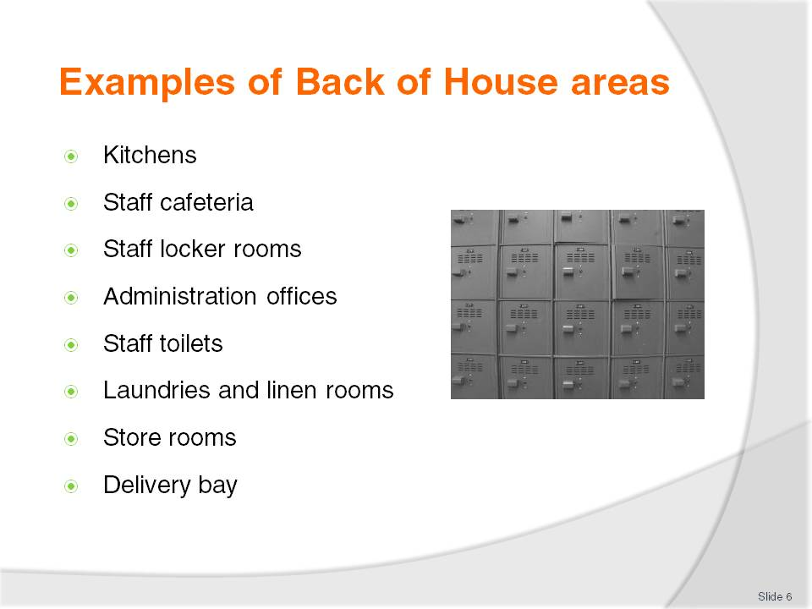
Slide No | Trainer Notes
Trainer to explain that back of house areas are where staff work and to where guests do not have access:
Kitchens may be cleaned by a team of stewards who report directly to the Executive Chef
In small motels however, cleaning may be undertaken by housekeeping staff.

Slide
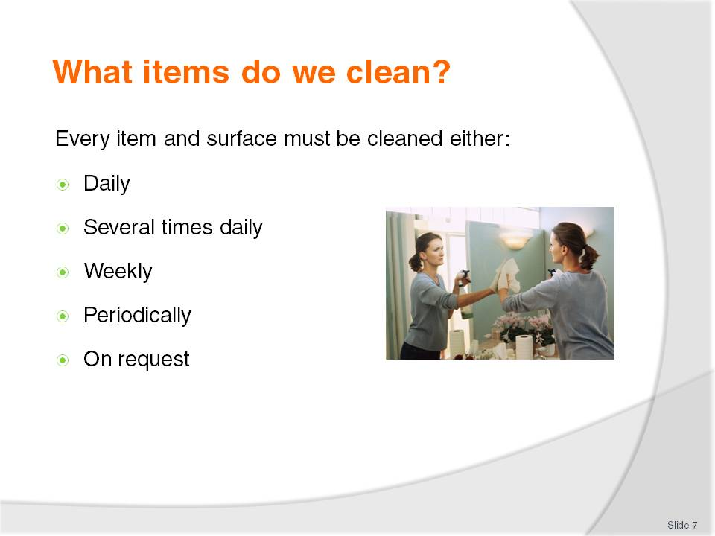
Slide No | Trainer Notes
Class activity 3
Trainer to have groups of students assigned to one area in their workplace and identify each item, each surface type and how often they think each item would need cleaning.
Consider the volume of customers and staff expectations
Discuss the students’ findings as a whole.

Slide
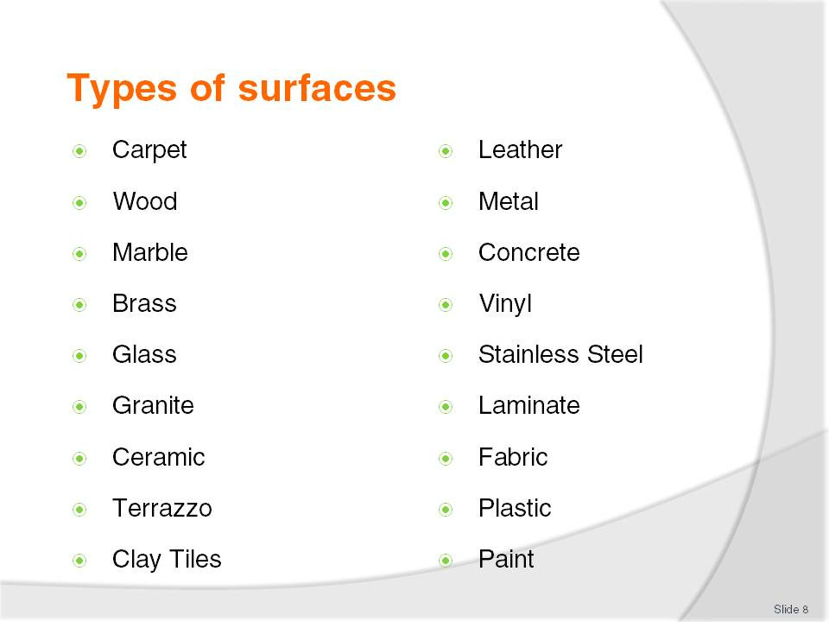
Slide No | Trainer Notes
 | Based on Activity 3, trainer should show students some examples of where all the above may be located so that students can recognise all types of surfaces.

Slide
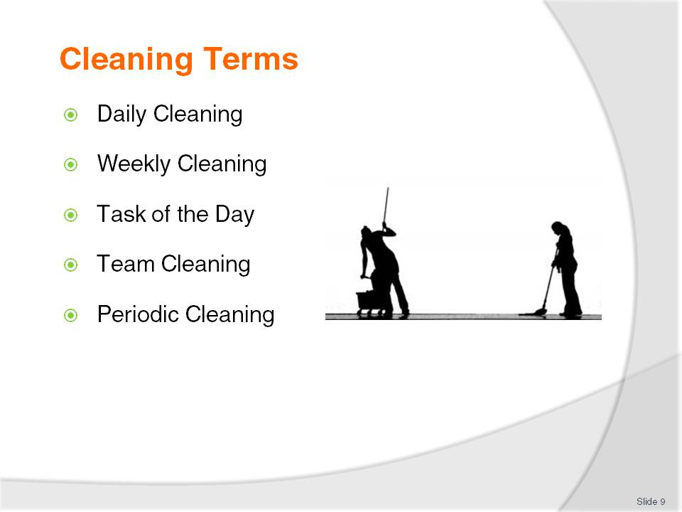
Slide No | Trainer Notes
 | Trainer to explain these terms and how they relate to frequency of cleaning.

Slide
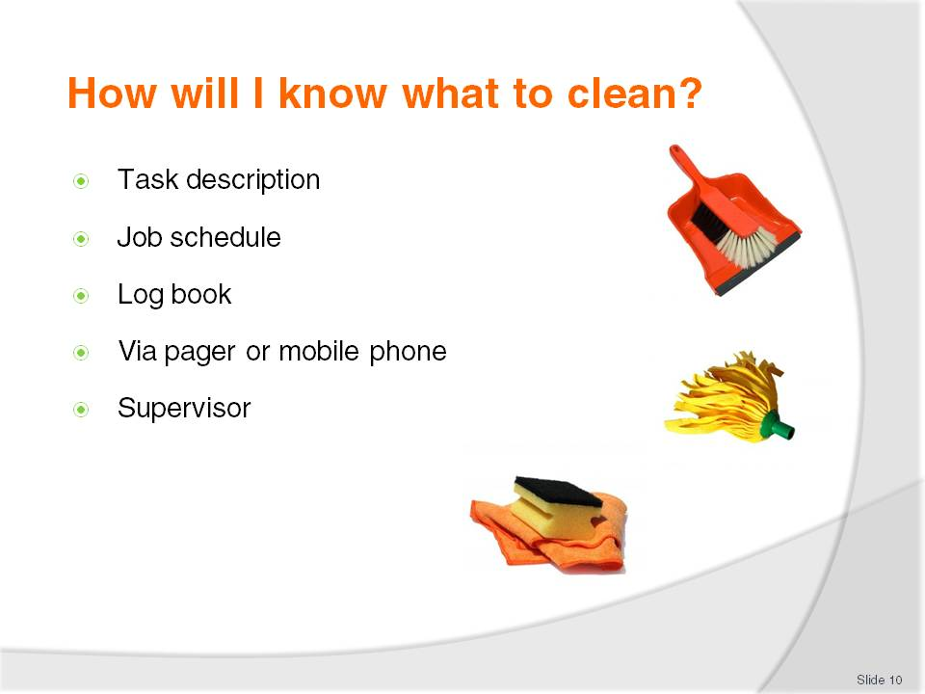
Slide No | Trainer Notes
There will be a variety of communication tools in the workplace.
Trainer should discuss these and ask the students if they have any more examples.
Discuss the importance of good communication and its effect on customers if there is a breakdown on communicating cleaning requirements
On occasions other staff will make cleaning requests directly to the cleaners for action
Always refer these requests to your supervisor as they will need to know what you are doing and possibly why other cleaning tasks have not been completed.

Slide
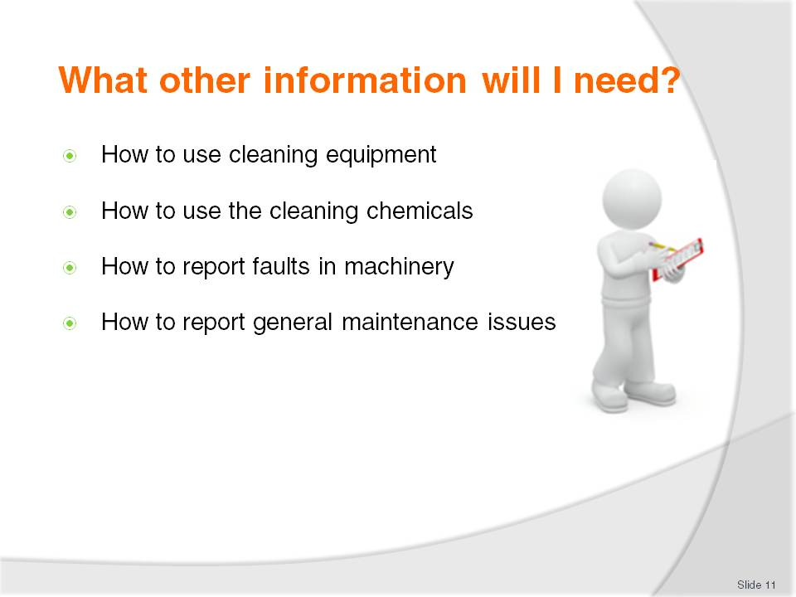
Slide No | Trainer Notes
Trainer to obtain samples of MSDS, colour wall charts, and technical bulletins for chemicals and discuss each one in detail.
Class activity 4
Have the students design a maintenance request procedure and reporting form.

Slide
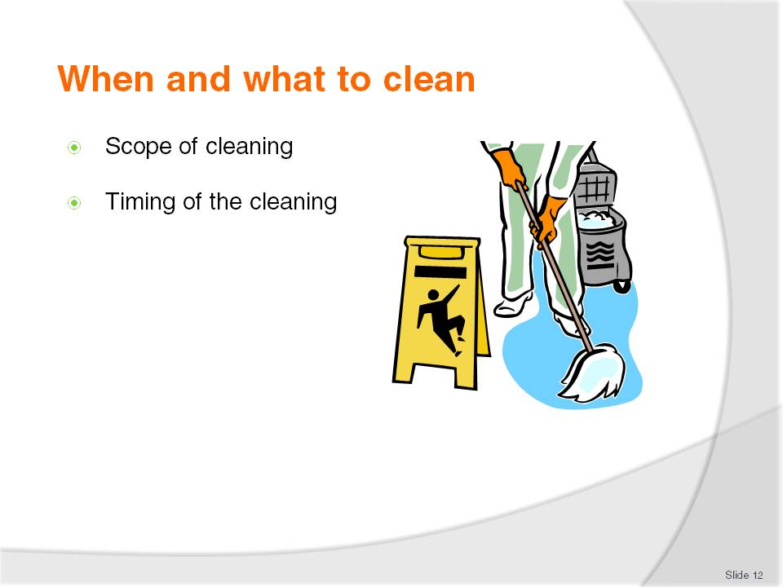
Slide No | Trainer Notes
 | Trainer to discuss this in relation to trading rosters and requirements of this cleaning.

Slide
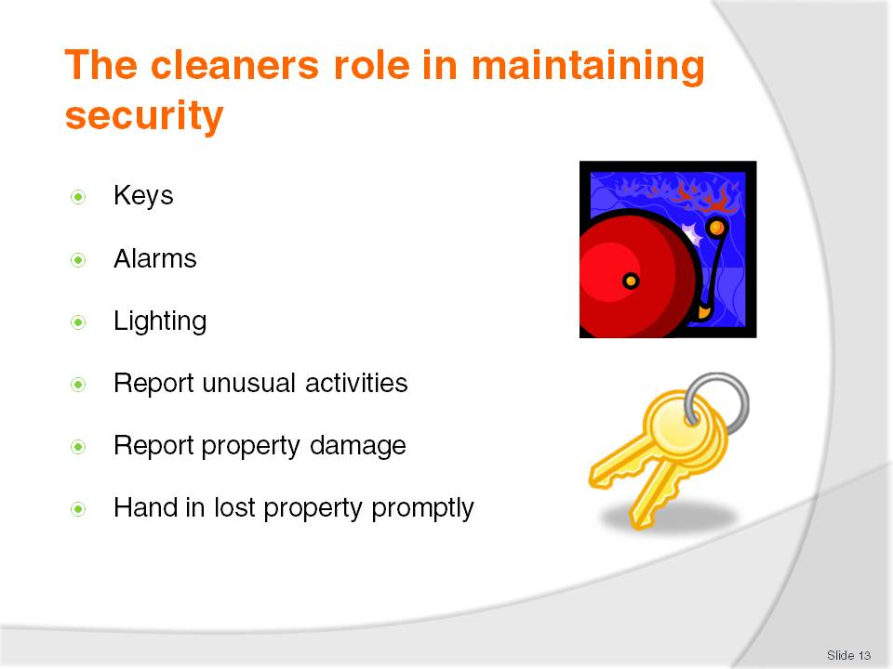
Slide No | Trainer Notes
Trainer to emphasise how important this role is. They must help to secure the building and its assets.
Trainer to stress the importance of the care of keys and assets.
Discuss in detail the reasons for reporting unusual activities and have the students discuss their experiences in the workplace in relation to security issues.

Slide
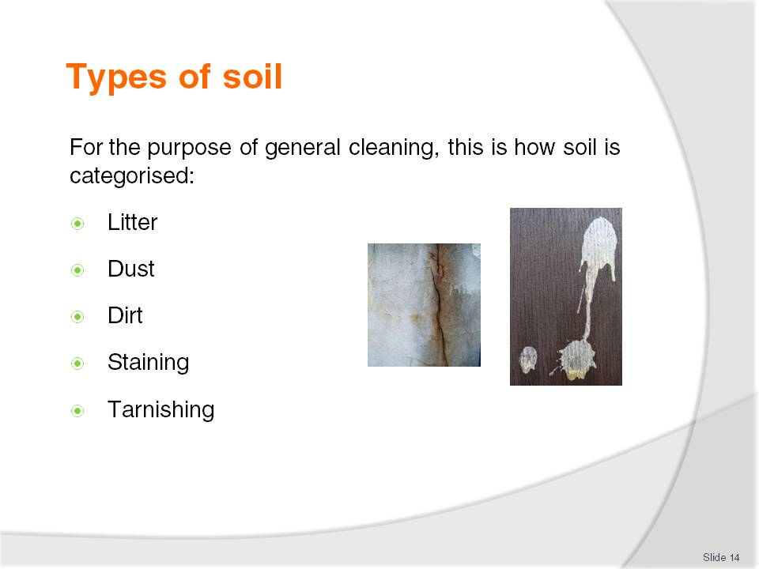
Slide No | Trainer Notes
 | Self explanatory - Trainer to give examples of all of these in a public building.

Slide
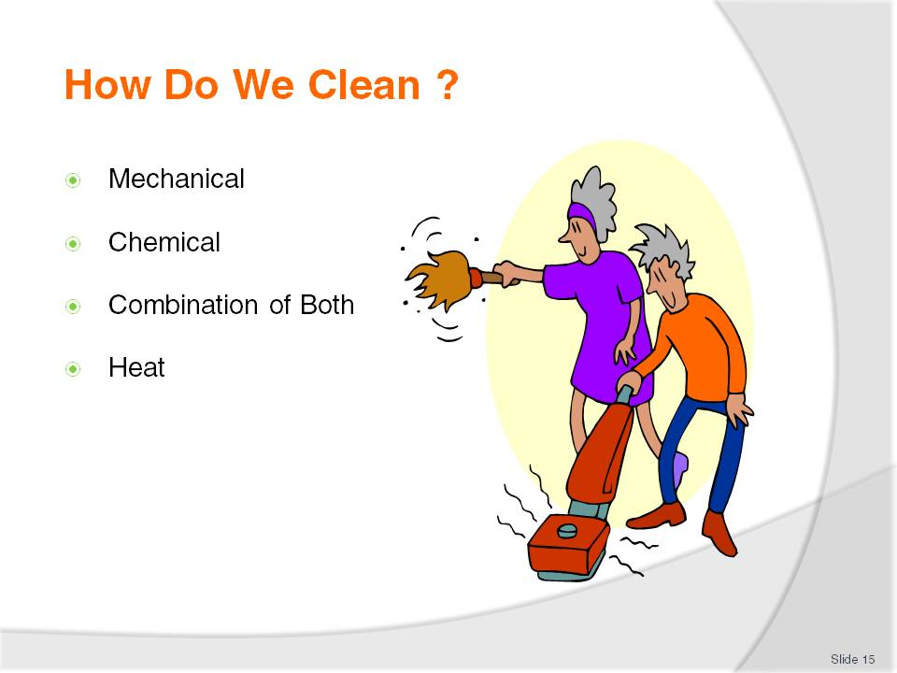
Slide No | Trainer Notes
Trainer to explain that cleaning is a science which is constantly evolving.
A good knowledge of machinery, chemicals and cleaning techniques is vital
Most cleaning methods involve a combination of mechanical action either human or machine and chemicals
Heat is used for sterilisation.

Slide
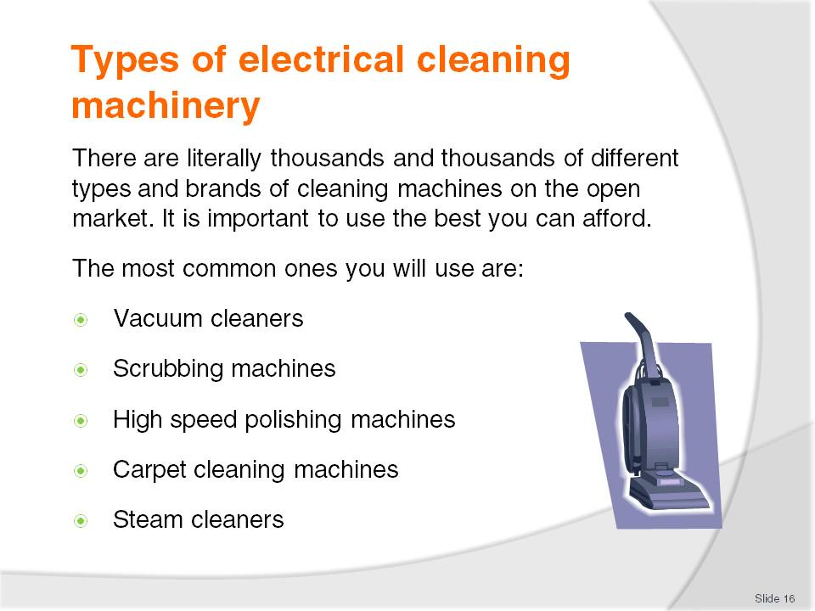
Slide No | Trainer Notes
Trainer should discuss in detail the operation of each machine.
The use of these includes mechanical action.
Class activity 5
If possible have one of each machine in class to demonstrate to students.

Slide
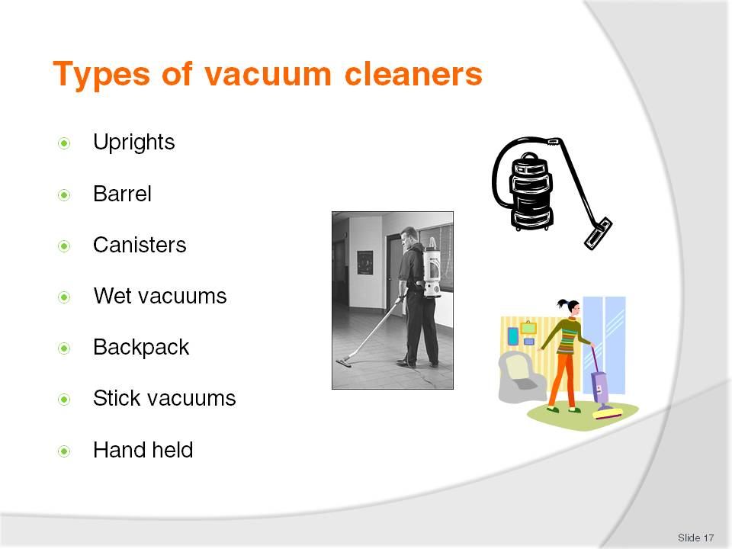
Slide No | Trainer Notes
Trainer to discuss that in hotels, carpet will probably occupy 60% of all flooring.
The vacuum cleaner is the most important piece of electrical equipment used by the professional cleaner and should be well cared for.

Slide
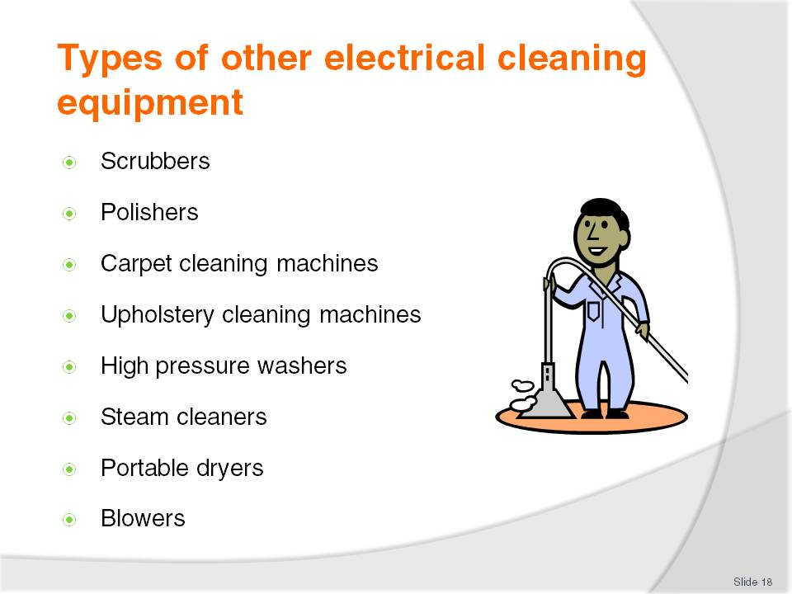
Slide No | Trainer Notes
Trainer to explain that scrubbers are usually classified as slow rotation machines (approximately 150 rpm-300 rpm).
Polishers can vary from 150 rpm to 2500 rpm
The latter (2500 rpm) are classified as burnishers which are only used to polish floors
The slower rotating machines can be used to scrub, strip floors (remove polish), polish and buff floors (Buffing is a maintenance method of cleaning the floors between strip and polish procedures)
Buffing may be done daily or weekly where strip and polish is done as needed, depending on the amount of foot traffic. Maybe every 3 or 6 months.
Trainer to discuss other types of machinery and where they will be used.

Slide
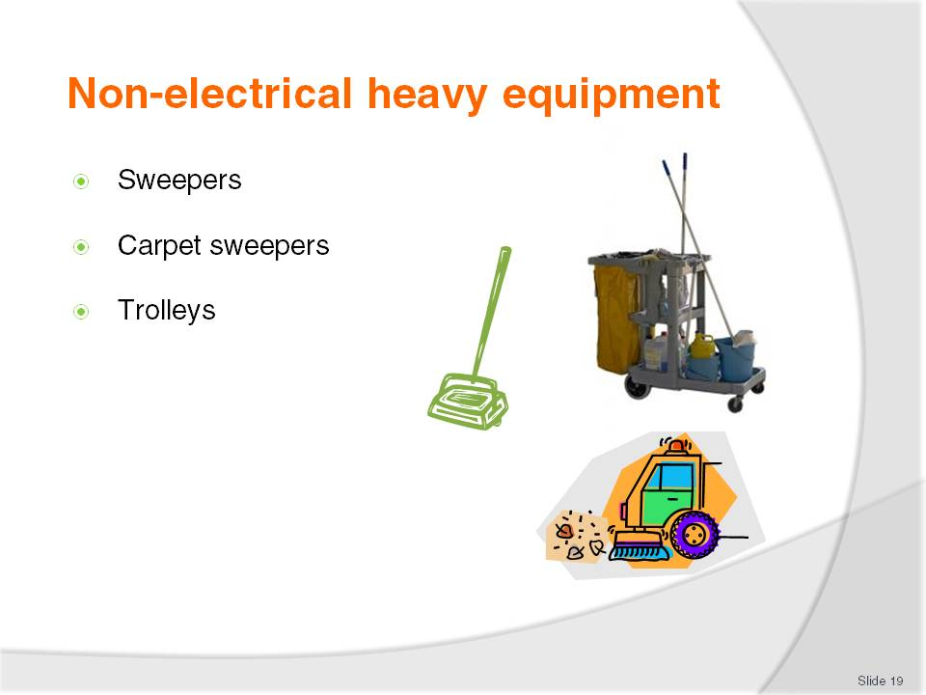
Slide No | Trainer Notes
Trainer to discuss the different types of sweepers (manual, battery driven and ride on).
Trainer should get brochure samples or pictures of different styles of cleaners trolleys and discuss what items should be placed on them and how they should be stacked neatly and in clean condition.

Slide
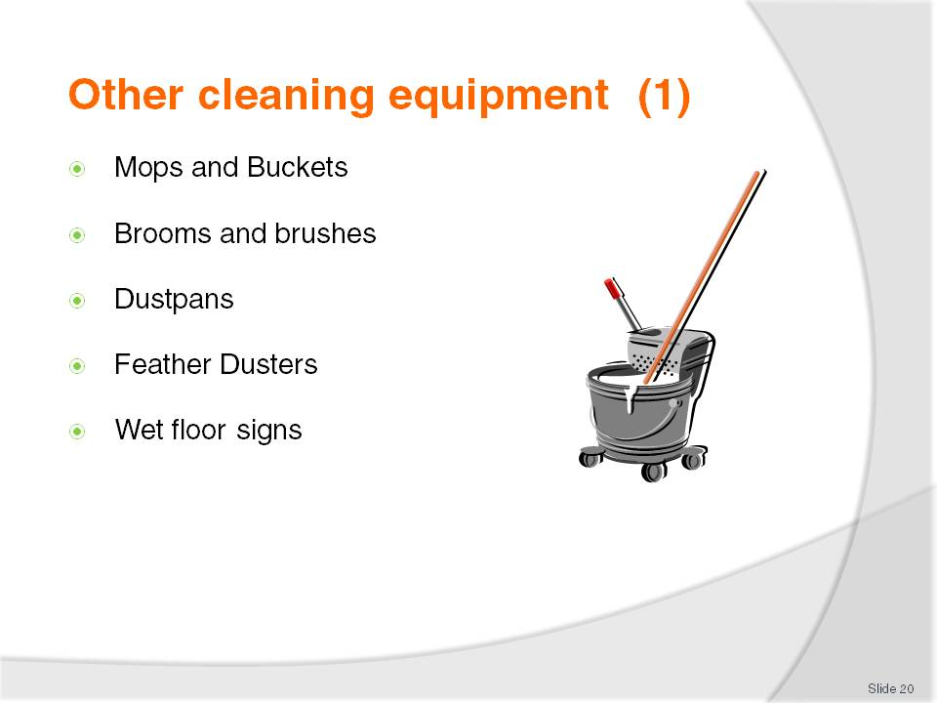
Slide No | Trainer Notes
Trainer to discuss various styles of mops and buckets, brooms and brushes.
Wet Floor signs or signs with Cleaning in Progress are vital as they alert guests and staff to possible hazards.
Dustpans may also include lobby pans which are the long handled style. These are for cleaning areas where there is always litter or cigarette butts.
It prevents the cleaner from having to bend all the time.
Continued next slide

Slide
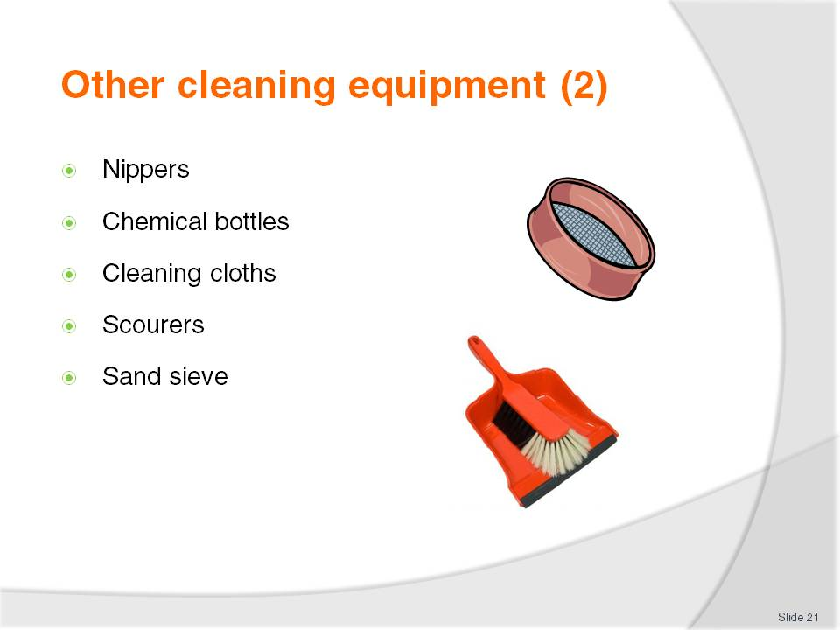
Slide No | Trainer Notes
Trainer to discuss.
Chemical bottles will be discussed later with selection of chemicals but mention that the bottles should ALWAYS be correctly labelled with the contents
A nipper is a piece of equipment used to pick up bottles and litter without touching it or bending. From here it is placed in to a garbage bag. It prevents the cleaner from having to bend all the time
A sand sieve is used to clean sand that is used in ashtrays
Scourers can be nylon or polyester and are abrasive pads - the darker the colour, the harsher they are. Green and white are used in most day to day tasks. Scourers should never be used on plastics or laminate. Brown and black are used in kitchens to remove grease.

Slide
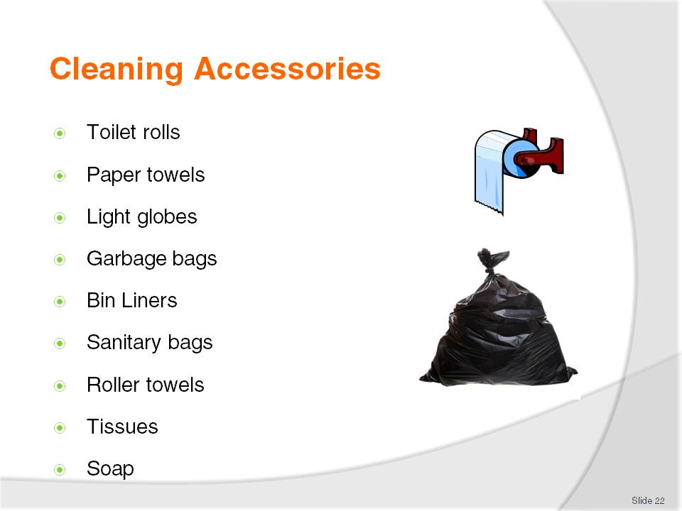
Slide No | Trainer Notes
Cleaning accessories are very important during the cleaning process
All staff must be able to replace vital guest supplies like soap and toilet rolls as needed
Collection of rubbish must be done on a regular basis so garbage bags and bin liners are a part of the cleaning process.
Class activity 6
Suggest the trainer invite a guest speaker from a cleaning accessory company to discuss the wide variety of miscellaneous cleaning equipment and accessories available.

Slide
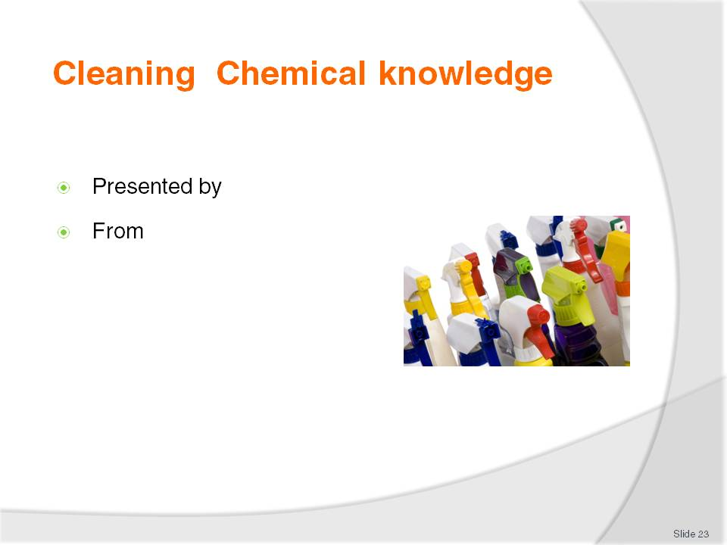
Slide No | Trainer Notes
Class activity 7
Trainer to invite a guest speaker from a reputable cleaning chemical supplier to discuss all aspects of use, selection, storage and safety.

Slide
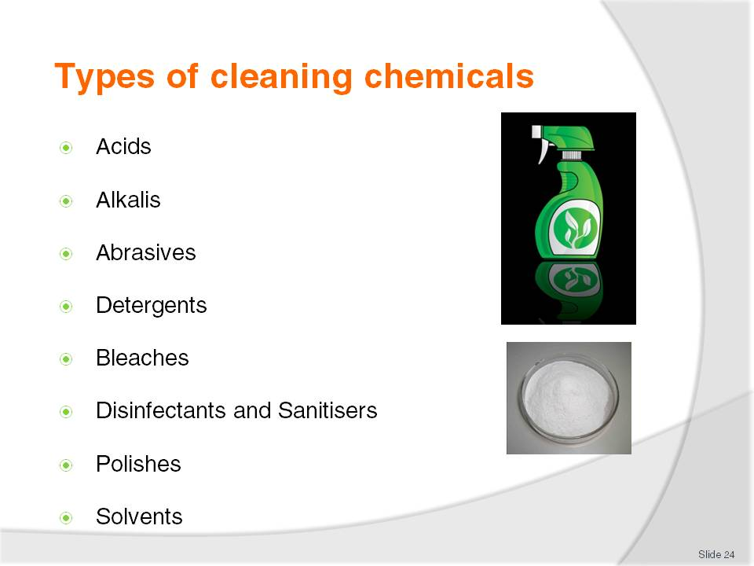
Slide No | Trainer Notes
 | Trainer to link this slide with the discussions with the chemical supplier representative and slides 25 and 26.

Slide
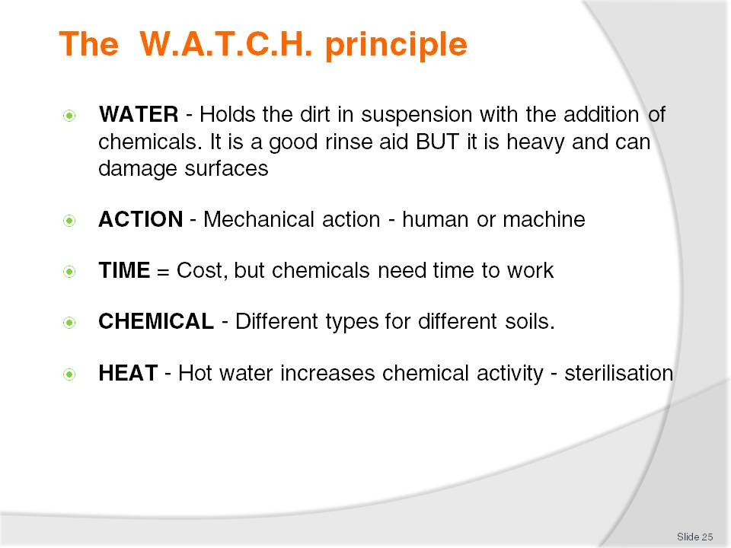
Slide No | Trainer Notes
Water is a necessary addition to most chemicals as it helps the chemical to penetrate the soil and hold it in suspension so it can be easily rinsed away
Care must be taken when using water on wood floors as it is can swell the wood. Take care not to over wet carpets
Water is heavy and can cause damage if not used correctly
Hot water will increase the activity of most chemicals.

Slide
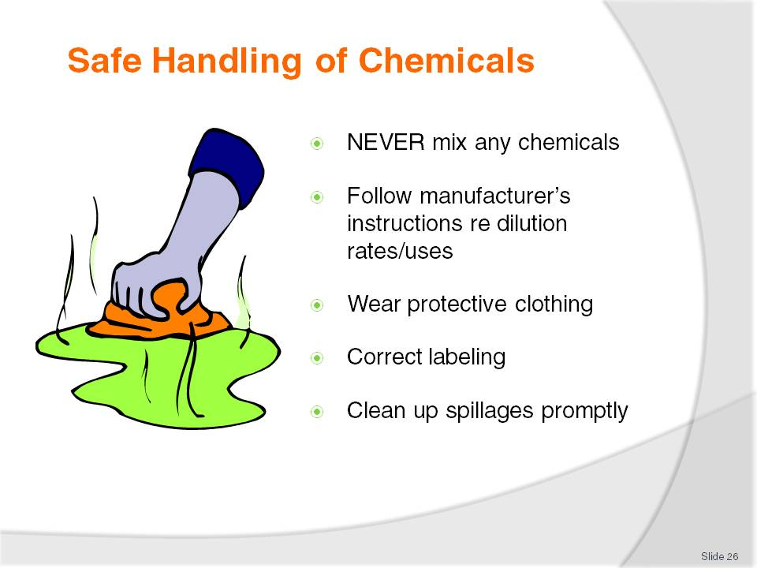
Slide No | Trainer Notes
Trainer to stress that chemicals should NEVER be mixed.
One may render the other inactive but also can cause a chemical reaction which can give off fatal gases
Always follow the instructions for use and know the purpose of each one
Refer to the general precautions in the Trainee Manual.

Slide
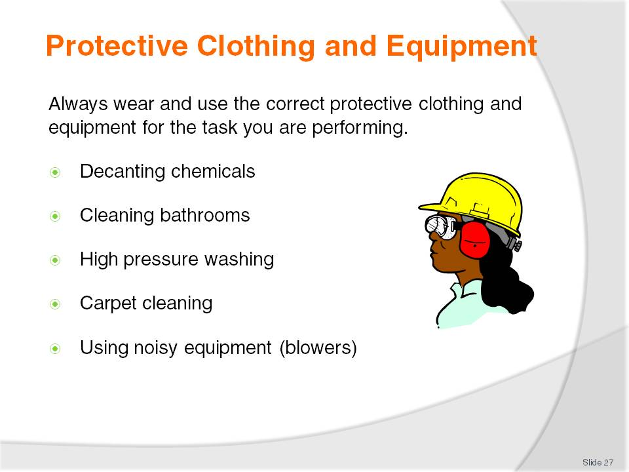
Slide No | Trainer Notes
Trainer to hold a general discussion on what to wear and when.
If possible have some examples to show the students.

Slide
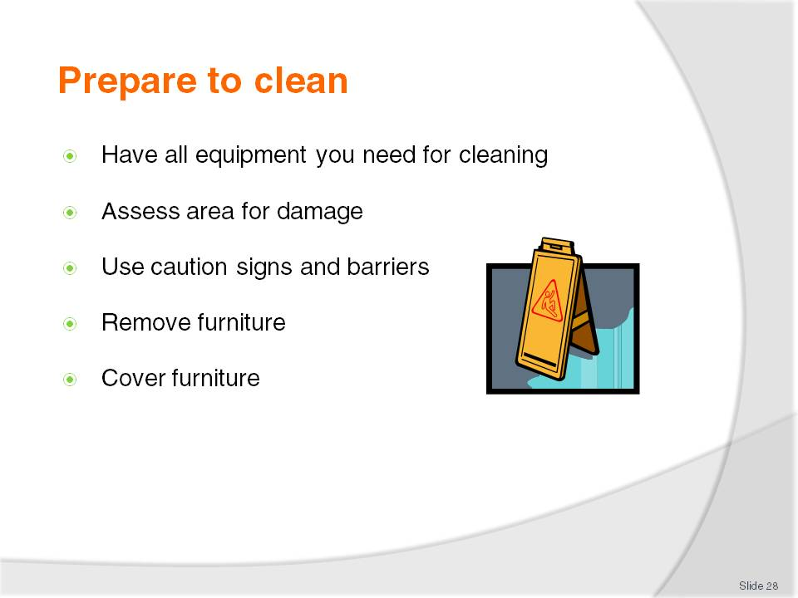
Slide No | Trainer Notes
 | Trainer to explain that good preparation will save time in the long run.

Slide
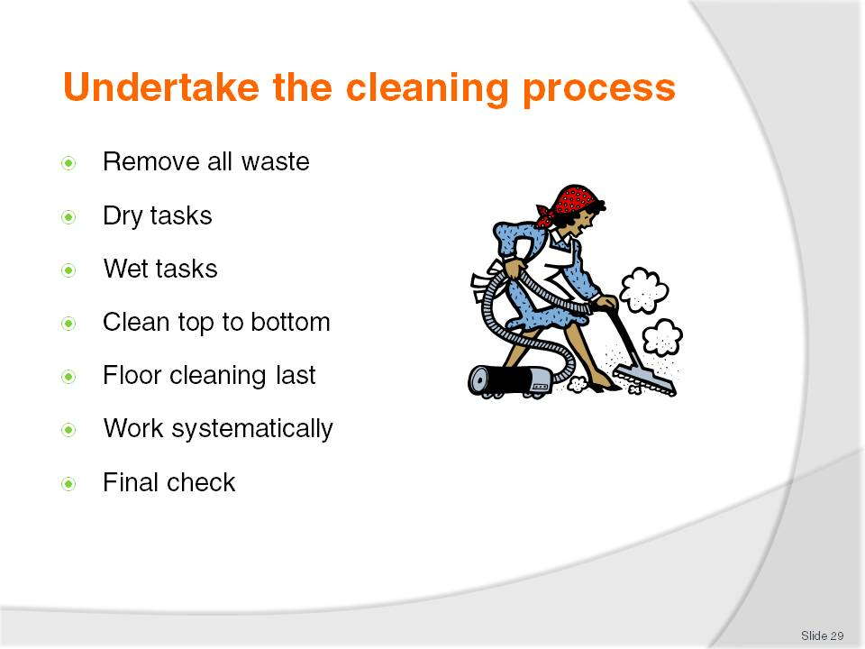
Slide No | Trainer Notes
Trainer to explain that working to a routine will ensure that no tasks are missed and all surfaces will be cleaned.
A routine will ensure that time is not wasted backwards and forwards changing chemicals and equipment
At the end of the day, the cleaner will also be less tired.

Slide
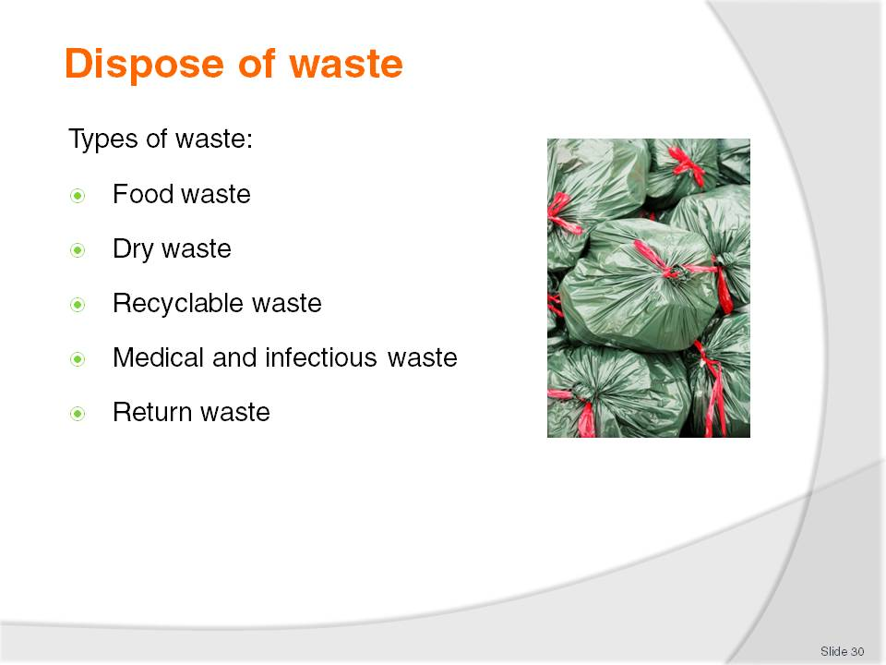
Slide No | Trainer Notes
Trainer to explain that disposal of waste is a very important task.
Explain that f waste is not disposed of correctly; it may attract vermin and pests and generate bad odours.
Class activity 8
Suggest trainer arrange a visit to either a waste disposal plant to see how all waste is disposed of or a visit to a recycling plant to create awareness in the students of the need to recycle and reduce costs of general waste disposal.

Slide
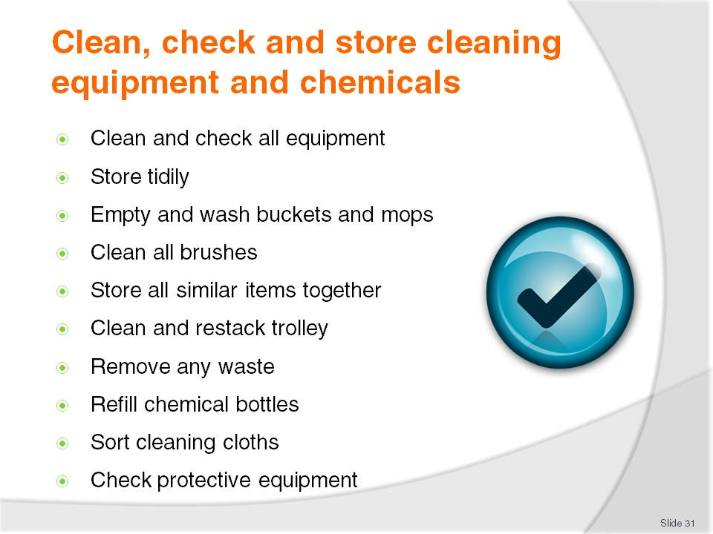
Slide No | Trainer Notes
 | Trainer to discuss these issues explaining that good teamwork between cleaners will make their tasks easier for the next day as the cleaners store will be neat and tidy, all equipment in working order and everything in its place will save time and effort.

Slide
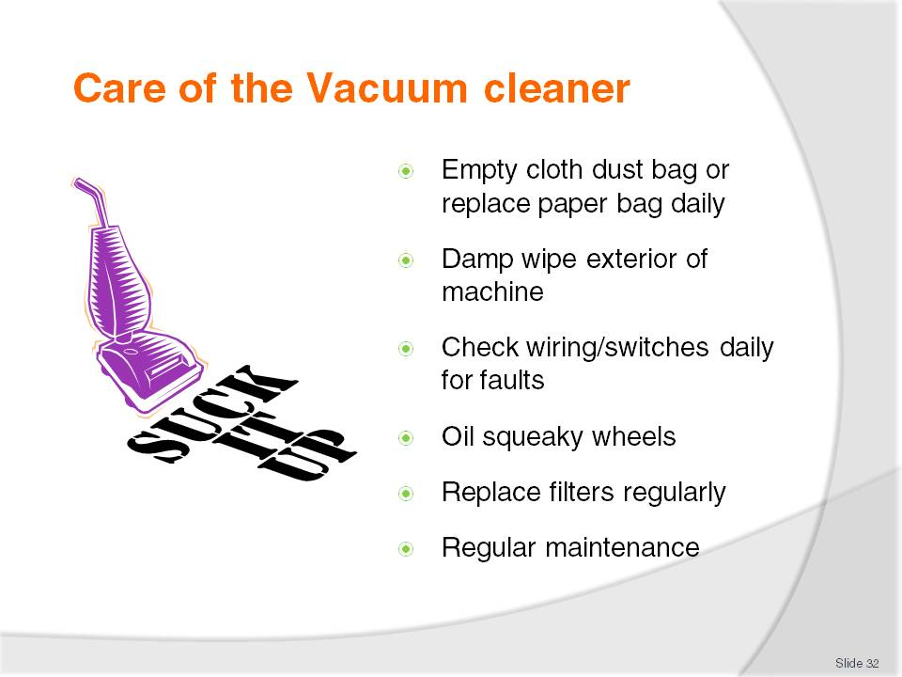
Slide No | Trainer Notes
The vacuum cleaner should be well maintained
Always place the full paper dust bag into a plastic garbage bag to eliminate dust being spread around
The machine should be checked daily for frayed or damaged wiring
Report faults as soon as they occur and take a machine out of service if it presents as a hazard
Squeaky wheels or an overly noisy motor may disturb guests and staff.

Slide
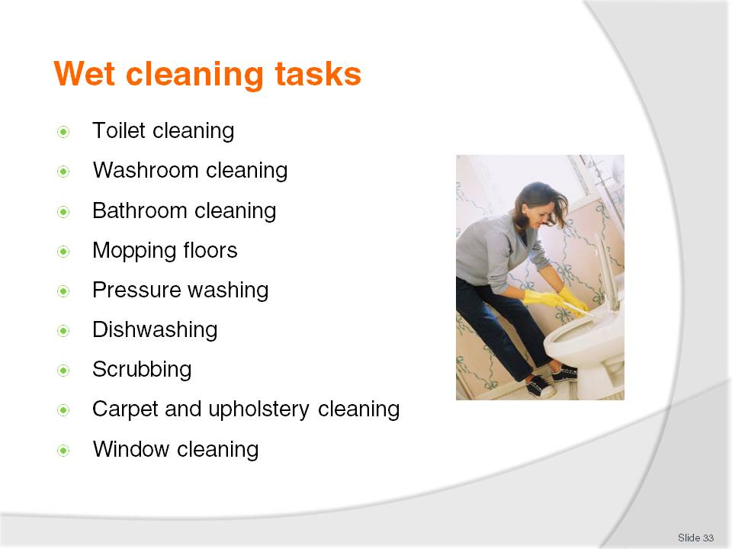
Slide No | Trainer Notes
Trainer to discuss different wet tasks and the equipment and chemicals that would be needed for each.
Trainer to demonstrate the correct cleaning of a) a toilet and b) a wash basin and point out all the details that determine if these areas are clean or not (tops of lid and seat, underneath of the lid and seat, around the pan and underneath, the throat of the toilet and under the rim, any pipes behind and the flush buttons or handles).
Dry and polish - for a washbasin around the taps and plug, no hairs or cigarette butts, overflow outlet, pipes underneath, the underneath of the basin.

Slide
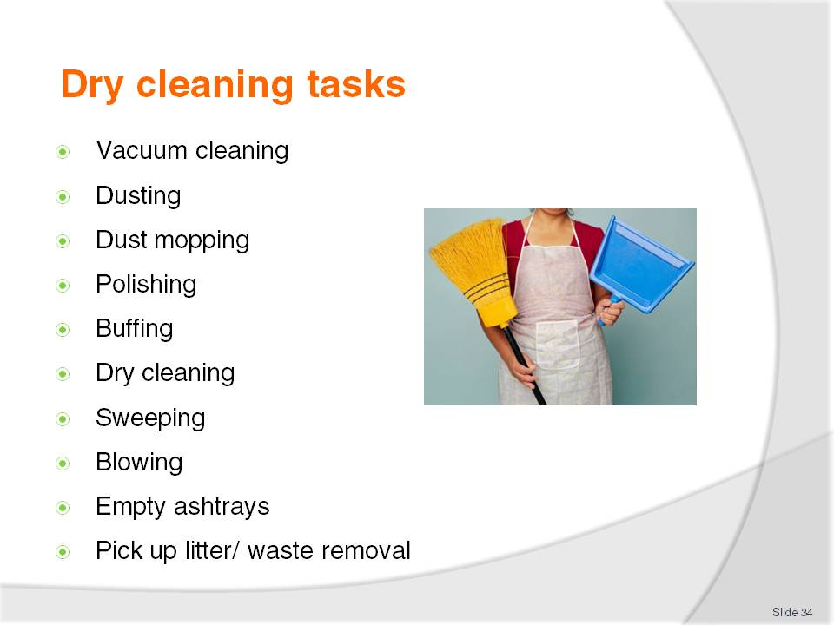
Slide No | Trainer Notes
Trainer should demonstrate the correct standing position when vacuuming (keep back straight and let the machine do the work - do not “scrub” the carpet with the machine.
When dusting, dampen the rag and spray the polish or all purpose cleaner on to the rag. This will be enough and economical
Demonstrate the figure 8 of dust mopping an area without lifting the mop off the floor.

Slide
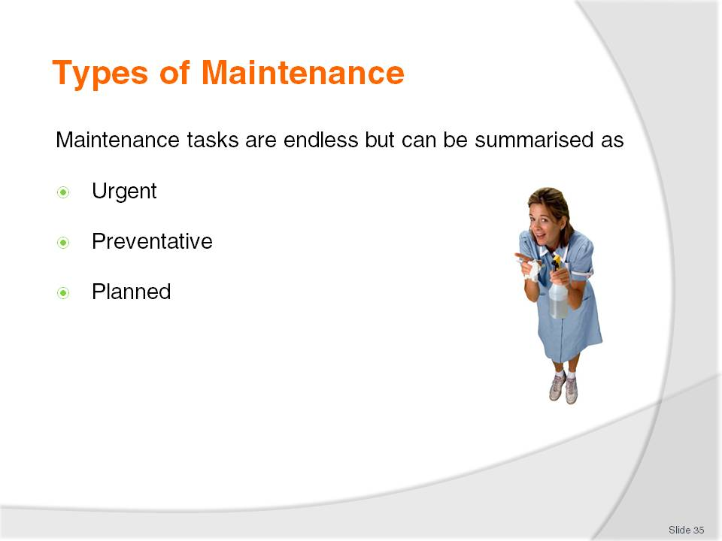
Slide No | Trainer Notes
Trainer to discuss.
All maintenance tasks need to be prioritised in order of urgency
Preventative is designed to prevent breakdowns and planned is usually larger tasks that need more time to be done at unusual times.
Class activity 9
Select an area and have the students identify all items that would need preventative maintenance by an electrician.

Slide
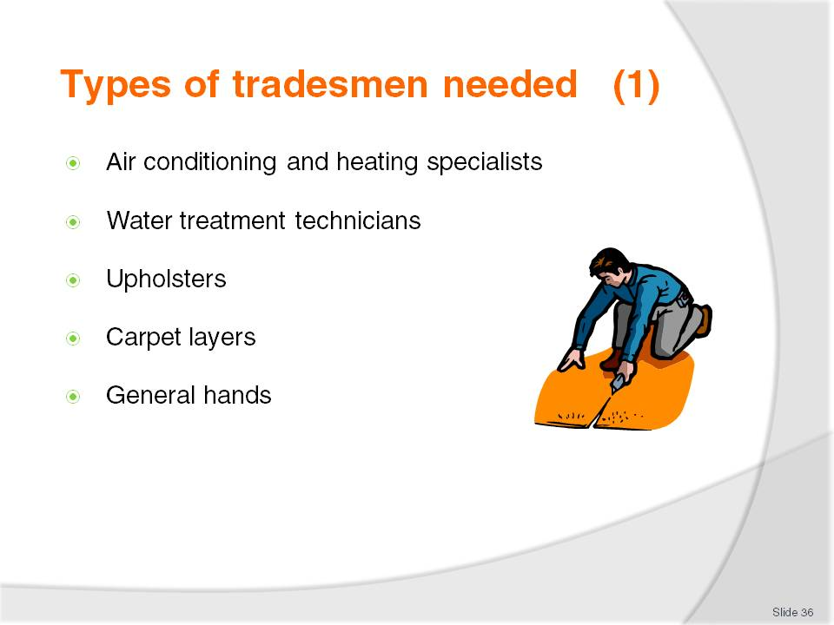
Slide No | Trainer Notes
 | Trainer to discuss the different tasks to be carried out by each.

Slide
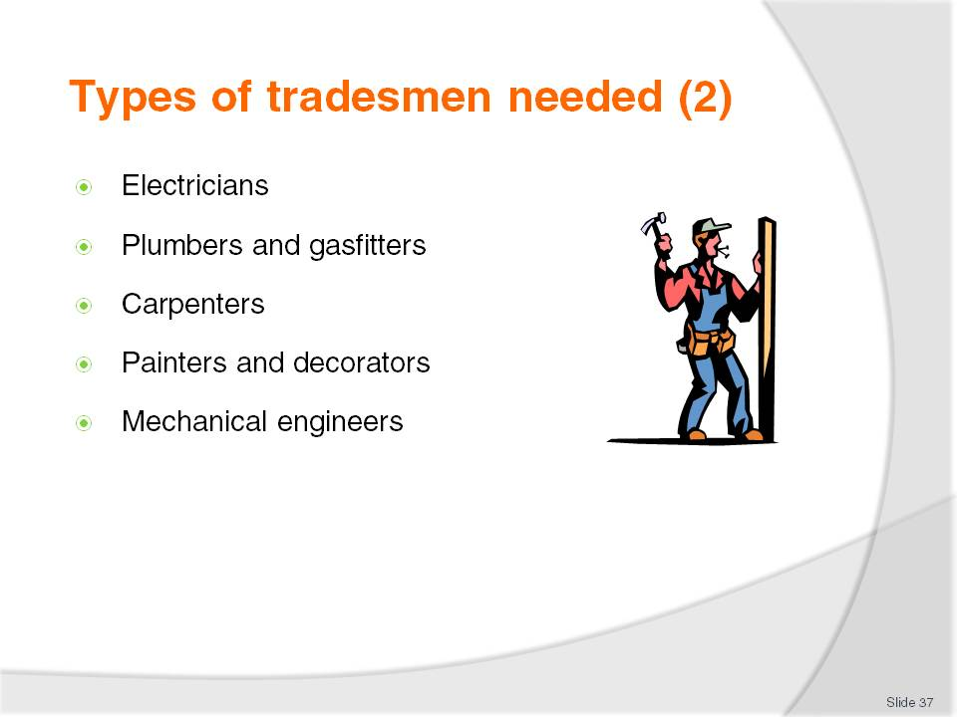
Slide No | Trainer Notes
 | Continue as previous slide.

Slide
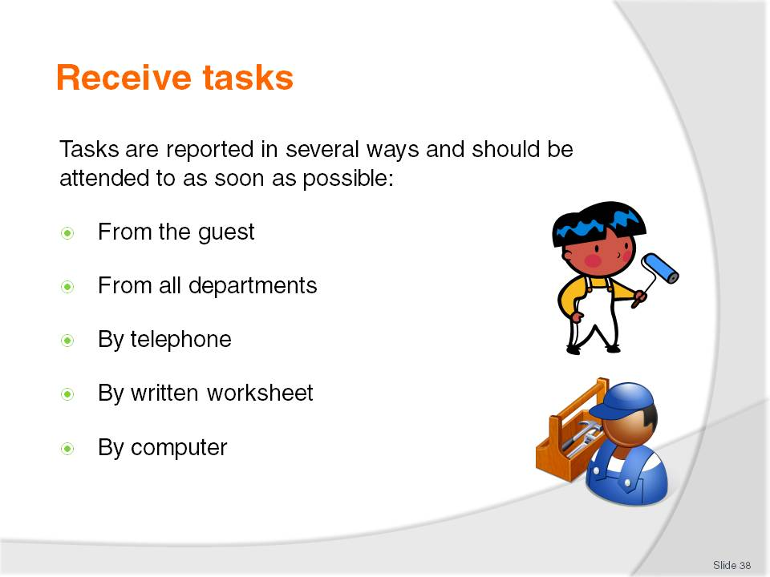
Slide No | Trainer Notes
 | Trainer to discuss in more detail.

Slide
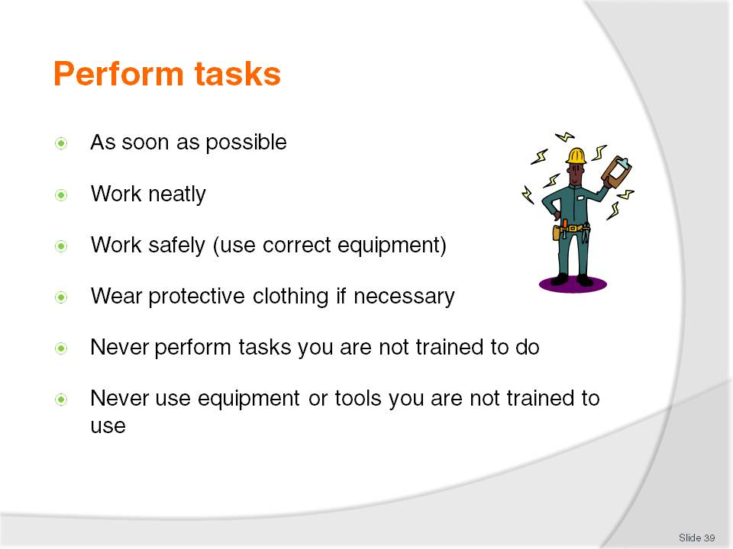
Slide No | Trainer Notes
Trainer to discuss.
Certain tasks should be carried out only by qualified people
To attempt to complete tasks you are not trained for may harm you or others or may damage property.

Slide
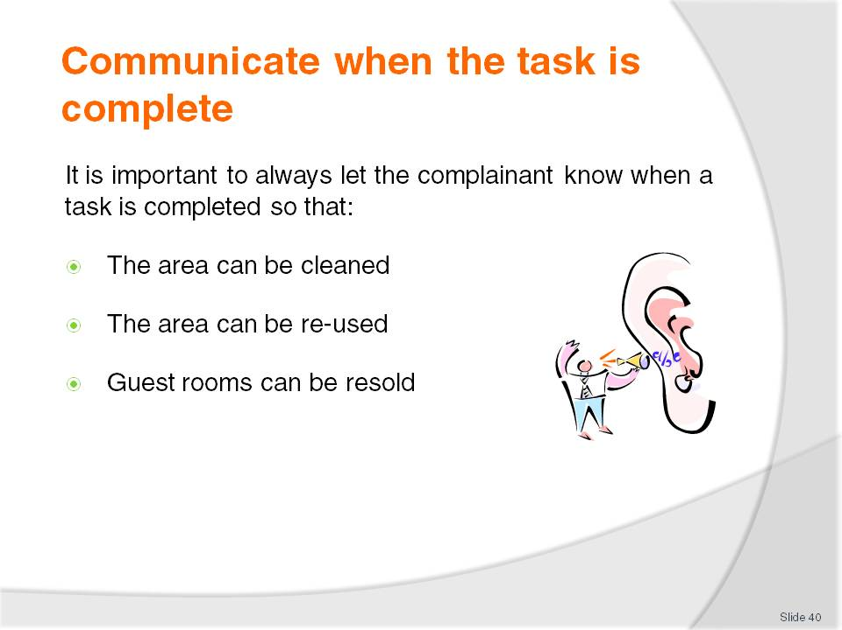
Slide No | Trainer Notes
Trainer to explain that maintenance staff have a critical role to play when areas are out of service due to a fault:
It may increase the workload for others but it is vital that there is good communication with all departments
E.g. if the main dishwasher in the kitchen is not working , it will cause inconvenience to the kitchen staff
If the machine has been fixed but this is not communicated, then there will a backlog of dirty dishes that could have been washed earlier
This may also cause departments to incur overtime as they need to catch up
Similarly, if Housekeeping is holding a room back because of a blocked toilet and nobody tells them the problem is fixed, the hotel could lose revenue due to the room not being available.

Slide
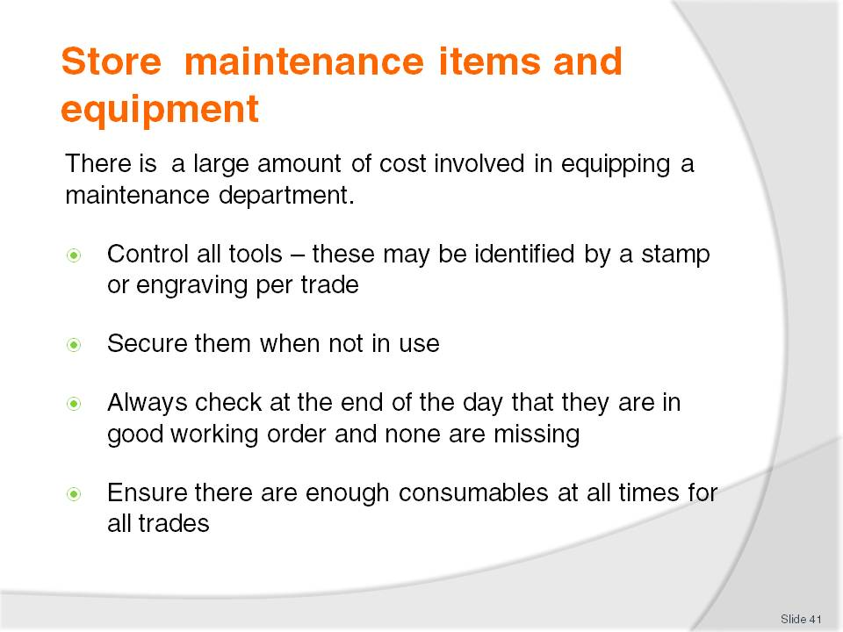
Slide No | Trainer Notes
This is self-explanatory.
Cost to the hotel is enormous if staff do not care for their equipment and it needs to be replaced
If there are not always the consumables needed, the tasks will be delayed and complaints may occur and revenue may be lost.

Slide
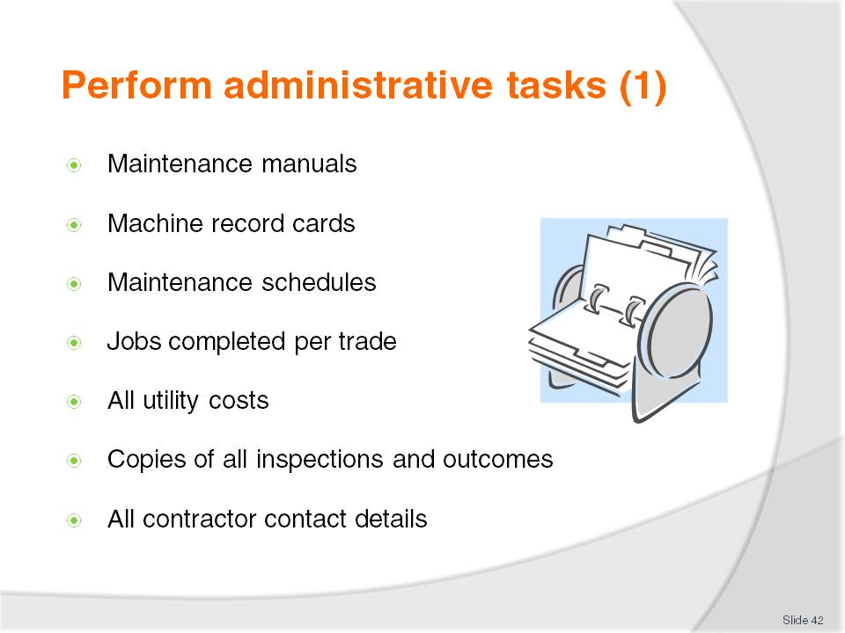
Slide No | Trainer Notes
 | Trainer to discuss all points.

Slide
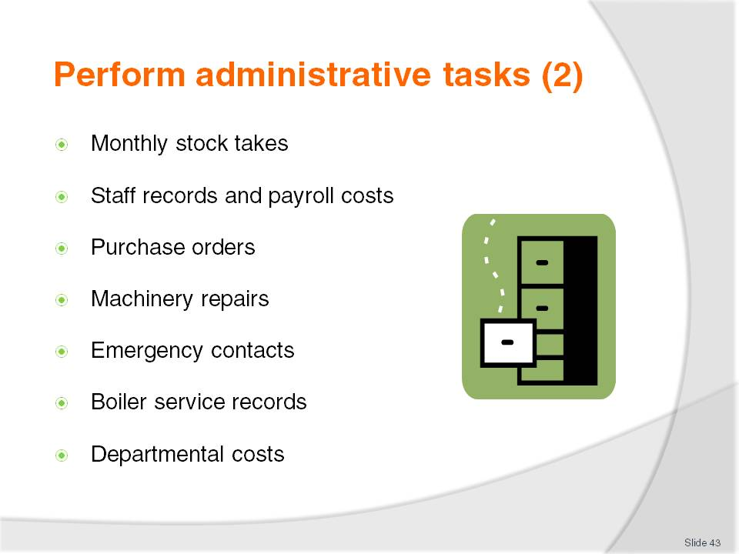
Slide No | Trainer Notes
 | Trainer to discuss all the necessary record keeping.

Slide
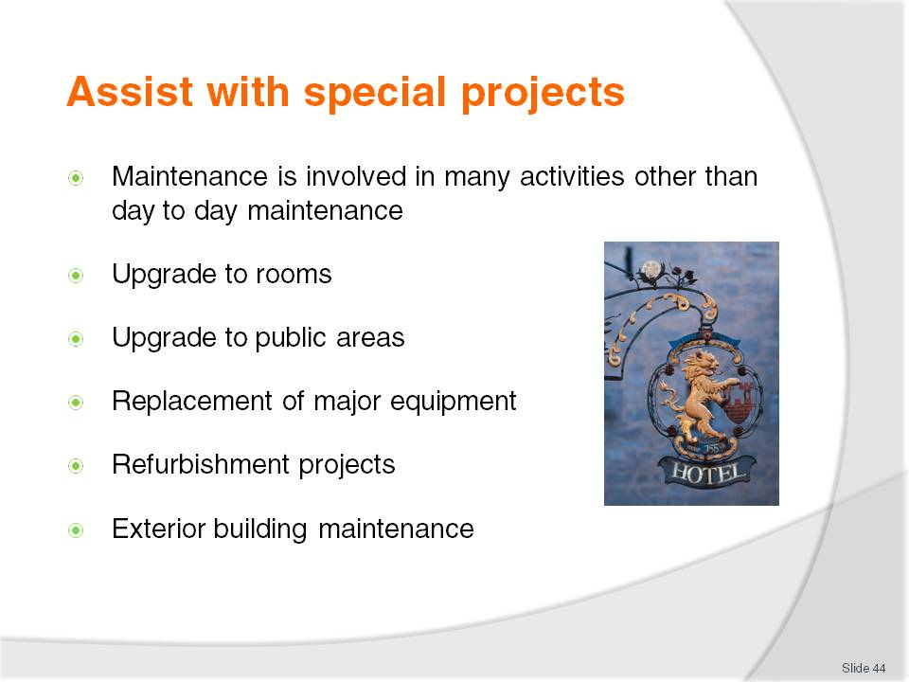
Slide No | Trainer Notes
Because maintenance staff know the layout of the building and the location of all plant and equipment, they must be involved with new projects when it involves upgrades and replacements within the building so that mishaps and accidents do not happen
Long term they will be responsible for the upkeep of any new equipment.

Slide
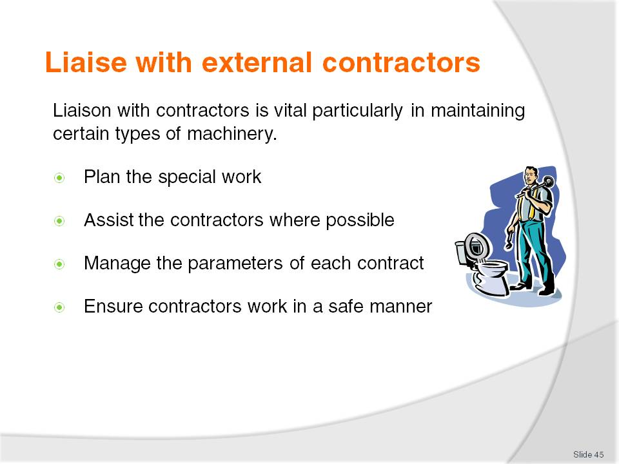
Slide No | Trainer Notes
Keep all necessary records of planned maintenance and call outs with reasons and cost
Review all contracts regularly to ensure that the best service for the price is obtained
Discuss advantages and disadvantages of using contractors.

Slide
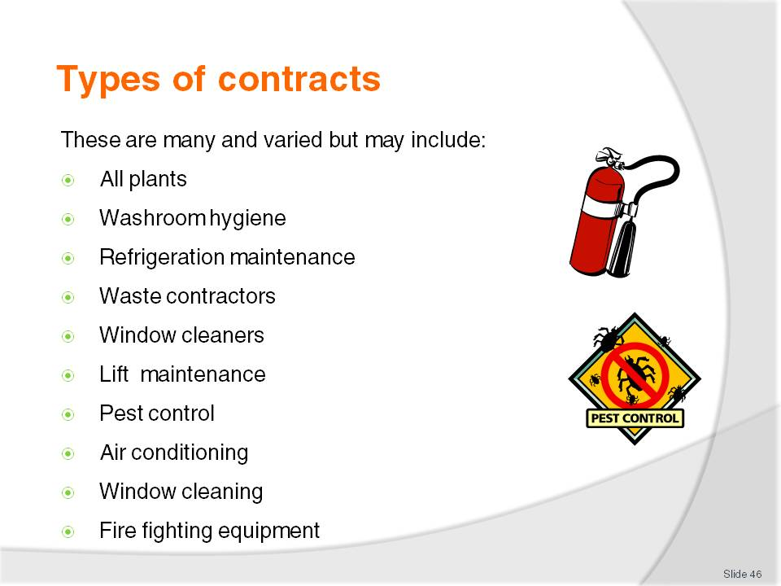
Slide No | Trainer Notes
 | Trainer to ask students if they have other contracts in their workplace.

Recommended training equipment
A copy of local Health regulations as they relate to cleaning of premises
Samples of different surface materials
Job descriptions
Task descriptions
Job schedules
Maintenance request forms
Chemical wall charts
Chemical MSDS
Chemical technical bulletins
Machine instruction manuals
Trading rosters
Banquet schedules
List of cleaning chemical suppliers
List of cleaning equipment suppliers both general and electrical
Samples of protective clothing
Access to areas for practical cleaning training e.g. toilets or restaurants
Varied array of electrical cleaning equipment
Varied array of general cleaning equipment
Varied array of cleaning accessories
Copies of inspection reports
Access to an array of tools and maintenance equipment and consumables
Copies of maintenance contracts
Access to a waste disposal plant.

Instructions for Trainers for using
PowerPoint – Presenter View
Connect your laptop or computer to your projector equipment as per manufacturers’ instructions.
In PowerPoint, on the Slide Show menu, click Set up Show.
Under Multiple monitors, select the Show Presenter View check box.
In the Display slide show on list, click the monitor you want the slide show presentation to appear on.
Source: http://office.microsoft.com
Note:
In Presenter View:
You see your notes and have full control of the presentation
Your trainees only see the slide projected on to the screen
More Information
You can obtain more information on how to use PowerPoint from the Microsoft Online Help Centre, available at: http://office.microsoft.com/training/training.aspx?AssetID=RC011298761033
Note Regarding Currency of URLs
Please note that where references have been made to URLs in these training resources trainers will need to verify that the resource or document referred to is still current on the internet. Trainers should endeavour, where possible, to source similar alternative examples of material where it is found that either the website or the document in question is no longer available online.

Appendix – ASEAN acronyms
AADCP | ASEAN – Australia Development Cooperation Program.
ACCSTP | ASEAN Common Competency Standards for Tourism Professionals.
AEC | ASEAN Economic Community.
AMS | ASEAN Member States.
ASEAN | Association of Southeast Asian Nations.
ASEC | ASEAN Secretariat.
ATM | ASEAN Tourism Ministers.
ATPMC | ASEAN Tourism Professionals Monitoring Committee.
ATPRS | ASEAN Tourism Professional Registration System.
ATFTMD | ASEAN Task Force on Tourism Manpower Development.
CATC | Common ASEAN Tourism Curriculum.
MRA | Mutual Recognition Arrangement.
MTCO | Mekong Tourism Coordinating office.
NTO | National Tourism Organisation.
NTPB | National Tourism Professional Board.
RQFSRS | Regional Qualifications Framework and Skills Recognition System.
TPCB | Tourism Professional Certification Board.







